Rosemary-Marinated Rib Eye Steaks with Lemon-Pepper Butter

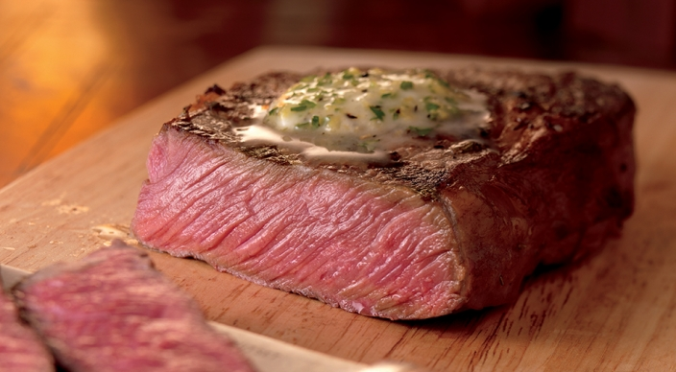
Marinade
- ½ cup extra-virgin olive oil
- 3 tablespoons roughly chopped fresh rosemary leaves
- 1 tablespoon minced garlic
- 2 teaspoons Dijon mustard
- ¼ teaspoon coarsely ground black pepper
- 4 boneless rib eye steaks, each 8 to 10 ounces and about 1 inch thick, trimmed of excess fat
Butter
- ½ cup (1 stick) unsalted butter, softened
- 1 tablespoon finely grated lemon zest
- 4 teaspoons fresh lemon juice
- ¾ teaspoon coarsely ground black pepper
- 1 tablespoon chopped fresh Italian parsley leaves

- Kosher salt
Instructions
- In a medium bowl whisk the marinade ingredients. Place the steaks in a large, resealable plastic bag and pour in the marinade. Press the air out of the bag and seal tightly. Turn the bag to distribute the marinade, place on a plate, and refrigerate for 2 to 24 hours, turning occasionally.
- In a small bowl blend the butter ingredients, including ½ teaspoon salt. Transfer the mixture to a sheet of plastic wrap and roll into a log about 1-½ inches thick. Refrigerate until firm, 45 minutes to 1 hour.
- Allow the steaks to stand at room temperature for 15 to 30 minutes before grilling.
- Prepare the grill for direct cooking over high heat (450° to 550°F).
- Remove the steaks from the bag and wipe off the excess marinade with your hands, leaving a thin coating. Season the steaks evenly with 1 teaspoon salt.
- Brush the cooking grates clean. Grill the steaks over direct high heat, with the lid closed as much as possible, until cooked to your desired doneness, 6 to 8 minutes for medium rare, turning once (if flare-ups occur, move the steaks temporarily over indirect heat). Remove from the grill, top with some of the lemon-pepper butter, and let rest for 3 to 5 minutes. Serve warm.

