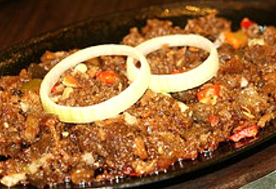
Sisig, the ultimate pulutan companion for beer. Around bars and restaurants, the many varieties of sisig dish is a best seller either to go along your favorite drink or to be chowed down with hot steamed rice.

Originally, sisig was made from chopped parts of a pig’s head — ears, snout, the brain, etc. Over the years it was reinvented into simple minced meat served on a sizzling platter with chili, liver, onion and seasoned with calamansi and vinegar.

Different orders of sisig come in pork, chicken, tuna, chorizo, bangus, and tofu. Adding raw egg on the dish while it’s sizzling hot heightens the flavor as well.

Estimated cooking time: 3 to 4 hours

Sisig Ingredients:
- 1-1/2 lbs pork cheeks (or 2 lbs deboned pork hocks)
- 1/2 lb beef or pork tongue
- 1/2 lb beef or pork heart
- 1/2 lb liver (pork, beef or chicken)
- 2 cups water (for boiling)
- 1 cup pineapple juice (for boiling)
- 1 tsp whole black peppers (for boiling)
Marinade seasonings:
- 1 cup chopped onions
- 3-4 finger hot peppers (siling labuyo) (seeded and chopped)
- 1/4 cup vinegar
- 1/4 cup calamansi juice (lemon juice)
- 1/4 cup pineapple juice
- 1 tbsp minced fresh ginger
- 1 clove garlic, minced
- 1 tsp whole black pepper (crushed)
- 1 pc bay leaf (crushed)
- Salt to taste

Sisig Cooking Instructions:
- Combine pork cheeks (or deboned pork hocks), heart, and tongue in pineapple juice, salt, water and crushed whole black pepper and bring to a boil; simmer for about 1 hour or until tender.
- Drain and cool to room temperature.
- Slice pork cheeks/hocks, liver, heart and tongue, into 2″X3″ X 1/4″ thick pieces.
- Place in bamboo skewers and grill over charcoal briquettes until pork rind is crisp and browned.
- Chop the grilled pork cheeks/hocks, liver, heart, and tongue into 1/4 inch sized cubes;
- Mix the chopped meat with the marinade seasoning mix of garlic, ginger, onions, vinegar, calamansi juice, hot peppers (siling labuyo), bay leaf, salt and pepper;
- Keep the marinated mixture in the refrigerator for 2-3 hours before serving.

