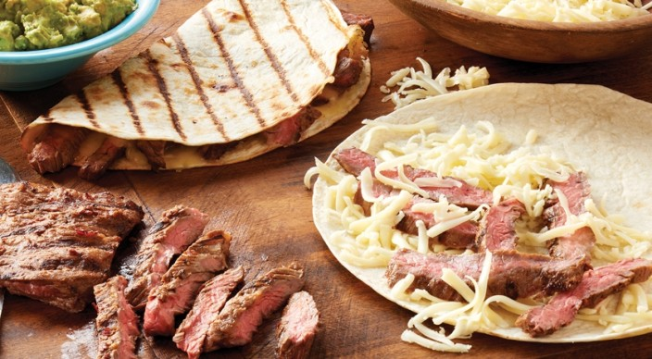
Skirt Steak Quesadillas
Marinade
3 tablespoons fresh lime juice
2 tablespoons vegetable oil
2 tablespoons minced canned chipotle chile peppers in adobo sauce
1 tablespoon minced garlic
1 teaspoon kosher salt
½ teaspoon ground cumin
½ teaspoon freshly ground black pepper

1½ pounds skirt steak, trimmed of excess surface fat, cut crosswise into 4-inch pieces

Guacamole
2 ripe Hass avocados, cut into ½-inch dice
⅓ cup finely chopped white onion, rinsed under cold water in a fine-mesh strainer
1 medium jalapeño chile pepper, seeded (optional) and minced
1 tablespoon finely chopped fresh cilantro leaves
2 tablespoons fresh lime juice
½ teaspoon kosher salt

6 flour tortillas (8 to 10 inches)
Vegetable oil
2¼ cups coarsely grated Monterey Jack cheese
Sour cream or plain Greek yogurt

In a large, resealable plastic bag combine the marinade ingredients. Place the steak in the bag, press the air out of the bag, and seal tightly. Turn the bag to distribute the marinade, place in a bowl, and refrigerate for 2 to 8 hours. Allow the steaks to stand at room temperature for 15 to 30 minutes before grilling.

In a medium bowl combine the guacamole ingredients and mash with a fork until combined but still slightly chunky. Cover with plastic wrap, with the wrap directly touching the guacamole, and refrigerate until ready to serve.

Prepare the grill for direct cooking over high heat (450° to 550°F). Remove the steaks from the bag and discard the marinade. Grill the steaks over direct high heat, with the lid closed, until cooked to your desired doneness, 4 to 6 minutes for medium rare, turning once. Remove from the grill and let the steaks rest for a few minutes. Cut the steaks across the grain into thin slices.

Lower the temperature of the grill for direct cooking over low heat (250° to 350°F). Lightly brush one side of each tortilla with oil. Place the tortillas, oiled side down, on a work surface. Assemble the quesadillas by distributing 3 tablespoons of the cheese on one half of each tortilla. Top the cheese with equal amounts of steak and another 3 tablespoons of cheese. Fold the empty side of the tortillas over the filling and press down.

Grill the quesadillas, in two batches if necessary, over direct low heat, with the lid closed, until golden on both sides, 4 to 6 minutes, turning once. Remove from the grill and let rest for about 1 minute. Cut the quesadillas into wedges and serve warm with guacamole and sour cream.

