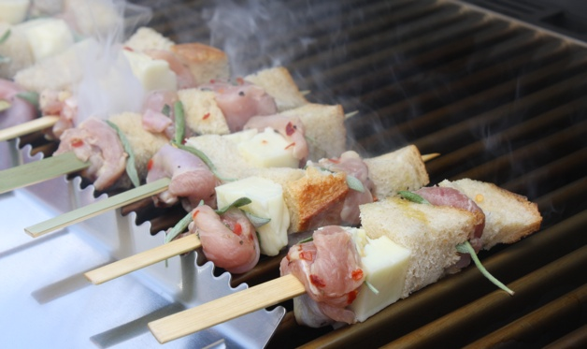
Mini Chicken Spiedini

1 bunch fresh sage
1 1/2 pounds skinless, boneless chicken thighs or breasts
1 teaspoon hot red pepper flakes
Sea salt and freshly ground black pepper
2 tablespoons extra-virgin olive oil
1 lemon, cut into 6 wedges
1 small loaf Italian bread, French bread, or other country-style bread, cut into 1/2- inch cubes
1 8-ounce chunk of halloumi or other firm grilling cheese, cut into 1/2-inch cubes

For the garlic-sage butter:

5 slivered sage leaves (from above)
1 clove garlic, minced
6 tablespoons salted butter

Step 1: Wash, shake dry, and stem the sage. Cut 10 sage leaves into thin slivers; leave the remaining leaves whole.

Step 2: Cut the chicken into 1/2-inch cubes and place in a large nonreactive bowl. Add half the slivered sage leaves, hot red pepper flakes, and lots of salt and pepper and toss to mix. Squeeze 2 lemon wedges over the chicken, then add the lemon rinds. Add the olive oil and toss to mix. Marinate the chicken in the refrigerator for 20 minutes while you cut the bread and make the garlic-sage butter.

Step 3: Assemble the spiedini: Thread the chicken pieces, bread cubes, cheese cubes, and whole sage leaves onto the skewers, alternating the ingredients. Refrigerate the spiedini until you’re ready to grill.

Step 4: Meanwhile, make the garlic-sage butter: Melt the butter in a small saucepan over medium heat. Add the remaining 5 slivered sage leaves and minced garlic and cook until they are fragrant and lightly browned, about 3 minutes. Remove the pan from the heat. The recipe can be prepared several hours ahead to this stage.

Step 5: Set up the grill for direct grilling and preheat to medium-high. When ready to cook, brush and oil the grill grate.

Step 6: Arrange the spiedini directly on the grill grate and grill 1 minute per side, turning 4 times. Start basting the spiedini with the garlic-sage butter and continue grilling until well browned on the outside and the chicken is cooked through, 4 to 6 minutes more, 8 to 10 minutes all, rotating the skewers so they cook on all sides.

Step 7: Serve at once, spooning any remaining garlic-sage butter on top and the remaining lemon wedges for squeezing.

