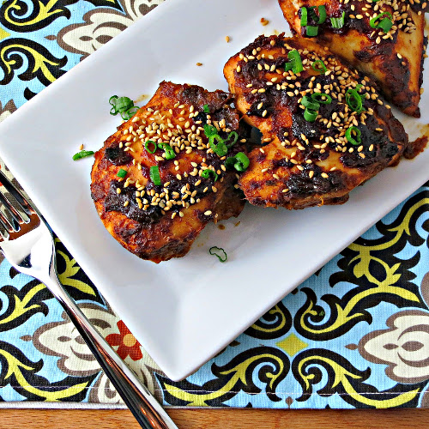
Oven-baked Sriracha Chicken

Ingredients
1 bunch green onions (greens (thinly sliced) and
whites (minced) separated)
¼ cup hosin sauce
1 tablespoon fresh ginger, minced (or grated)
2-3 garlic cloves, minced (or grated)
Pinch salt
2 tablespoons fresh lime juice
2 teaspoons sriracha sauce (adjust to taste)
¼ teaspoon Chinese five star seasoning
4 4-ounce boneless, skinless chicken breast
1 tablespoon toasted sesame seeds (for serving)

Instructions

Preheat oven to 400 degrees. Spray a 13 x 9 baking dish with cooking spray and set aside.

In a large bowl, whisk together the minced whites of the green onions, hoisin sauce, ginger, garlic, salt, lime juice, sriracha sauce, and seasoning.

Working with once piece at a time, place chicken breast in the bowl and coat with sauce (note: the sauce is pretty thick). Place chicken breast in baking dish and repeat with remaining pieces of chicken. Pour any remaining sauce over the chicken.

Cover baking dish with with foil. Bake for 35-40 minutes, or until chicken is thoroughly cooked. Place chicken on serving dish(es) and top with green onion greens and sesame seeds.

Notes
Make ahead tip: Prepare chicken and sauce per the above and refrigerate until ready. Take chicken out of the refrigerator and then preheat the oven. Bake as usual.

