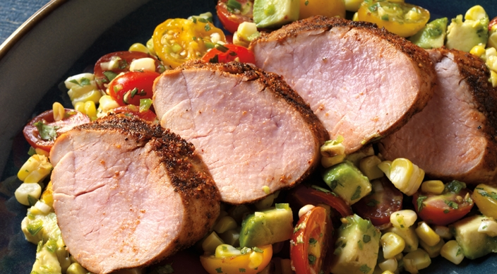
Tex-Mex Pork Tenderloin

Salsa
2 ears fresh corn, husked
Extra-virgin olive oil
1 cup red grape tomatoes, each cut
lengthwise in half
1 cup yellow grape tomatoes, each cut lengthwise in half
1/2 Hass avocado, cut into 1/4 inch dice
2 scallions (white and light green parts only), finely chopped
2 tablespoons finely chopped fresh cilantro leaves
1 jalapeño chile pepper, finely chopped
1/2 teaspoon kosher salt

Rub
2 teaspoons ground cumin
2 teaspoons packed dark brown sugar
1 1/2 teaspoons paprika
1 1/2 teaspoons kosher salt
1 teaspoon ancho chile powder
1 teaspoon granulated garlic
1 teaspoon onion powder
1/2 teaspoon freshly ground black pepper

2 pork tenderloins, each about 1 pound, trimmed of excess fat and silver skin

Instructions

Prepare the grill for direct cooking over medium heat (350° to 450°F).

Brush the cooking grates clean. Lightly brush the ears of corn with oil. Grill the corn over direct medium heat, with the lid closed, until they are browned in spots and tender, 10 to 15 minutes, turning occasionally. Remove from the grill and, when cool enough to handle, cut the corn kernels from the cobs. In a medium bowl combine the salsa ingredients and set aside until ready to use.

In a small bowl combine the rub ingredients.

Lightly brush the pork tenderloins all over with oil and season evenly with the rub. Allow the tenderloins to stand at room temperature for 15 to 30 minutes before grilling.

Brush the cooking grates clean. Grill the tenderloins over direct medium heat, with the lid closed, until the outsides are evenly seared and the internal temperature registers 145°F, 15 to 20 minutes, turning every 5 minutes. Remove from the grill and let rest for about 5 minutes. Cut the tenderloins crosswise into ½-inch slices. Serve warm with the salsa.

