Torrejas

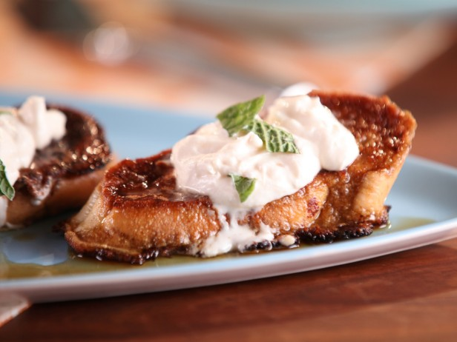
CREAM CHEESE WHIPPED CREAM:
- 3 ounces cream cheese, softened
- 1/2 teaspoon vanilla extract
- 3/4 cup cold whipping cream

GUAVA MAPLE SYRUP:
- 3/4 cup Grade-B pure maple syrup
- 1 cinnamon stick
- 1/4 cup guava marmalade

TOAST:
- 1 cup whole milk
- 2 tablespoons sugar
- 1 teaspoon vanilla extract
- 1/2 teaspoon ground cinnamon
- 6 eggs
- 12 slices Cuban or French bread, 1 1/2 inches thick
- 4 tablespoons unsalted butter
- 4 tablespoons vegetable oil, for frying

Fresh mint sprigs, for garnish

For the cream cheese whipped cream: Beat the cream cheese with the vanilla until smooth in a stand mixer fitted with a whisk attachment. Add the whipping cream and whip to soft peaks. Set aside while you make the French toast.

For the syrup: Combine syrup and cinnamon stick in a small saucepan. Bring to a simmer, and remove from the heat. Let syrup sit for 10 minutes to cool. Remove the cinnamon stick and return to heat. Bring the syrup to simmer again, and whisk in the guava. Serve warm.

For the toast: Preheat the oven to 275 degrees F. Whisk together the milk, sugar, cinnamon and eggs in a shallow bowl until smooth. Place the bread slices in a shallow dish and pour the egg mixture on top. While the bread soaks, heat 2 tablespoons of the butter and 2 tablespoons of the oil in a large saute pan or nonstick griddle over medium-high heat until the oil shimmers. Fry the bread in batches until golden brown on the bottom. Lower the heat slightly, flip the bread and cook until the bottoms are golden brown and the bread is cooked through as well. Keep warm in the oven while you make the remaining bread.

To serve, smear some cream cheese whipped cream on each piece of warm bread. Top with some of the guava maple syrup and a mint sprig.

