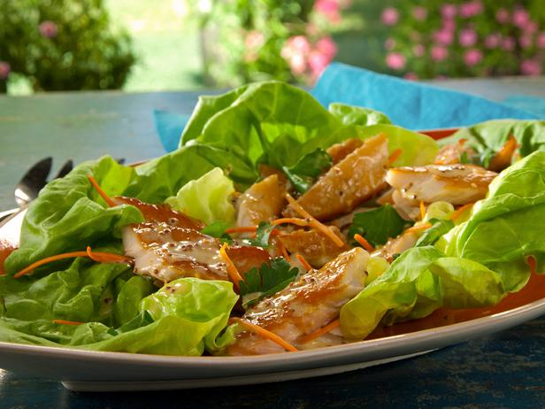
Ingredients
Trout:
1/2 cup kosher salt
2 tablespoons light brown sugar
8 rainbow trout fillets
Meyer Lemon Dressing:
1/4 cup freshly squeezed Meyer lemon juice
2 tablespoons mayonnaise
1 heaping tablespoon whole grain mustard
1 tablespoon red wine vinegar
2 teaspoons honey
1/2 teaspoon finely grated lemon zest
Kosher salt and freshly ground pepper
1/2 cup extra-virgin olive oil
Assembly:
1 head butter lettuce, leaves separated
1 carrot, julienned or grated
1 cup fresh parsley leaves
Special equipment: Pecan or apple wood chips.
Directions:
For the trout: Combine 4 cups water, the salt and sugar in a 4-quart container and stir until the salt dissolves, 1 to 2 minutes. Add the trout, making sure they are submerged. Cover the container and refrigerate for at least 1 hour and up to 3 hours.
Remove the trout from the brine, rinse thoroughly with cold water and pat dry. Place the trout skin-side down on a rack set in a half baking sheet. Place the rack in the refrigerator for drying, 21 to 24 hours or until the trout skin becomes shiny and somewhat tacky to the touch.
Prepare the smoker using pecan or apple wood chips so that it maintains a temperature of 190 degrees F. Place the trout onto the smoking racks, skin-side down, separating them by at least 1/4-inch. Place the smoking racks in the smoker. Adjust the heat as needed and cook until the trout is cooked through, has darkened in color and has the desired level of smoke flavor, about 20 minutes. Remove the flesh from the bones of the trout and flake the trout into medium pieces.
For the Meyer lemon dressing: Whisk the lemon juice, mayonnaise, mustard, vinegar, honey, zest and sprinkle with salt and pepper in a medium bowl. Slowly whisk in the oil until emulsified.
For the assembly: Place several pieces of the trout into individual lettuce leaves, drizzle with some of the Meyer lemon dressing and top with the carrots and parsley. Roll the lettuce leaves and eat.
Cook's Note: If Meyer lemons are not available, substitute 3 tablespoons freshly squeezed lemon juice plus 1 tablespoon freshly squeezed orange juice.

