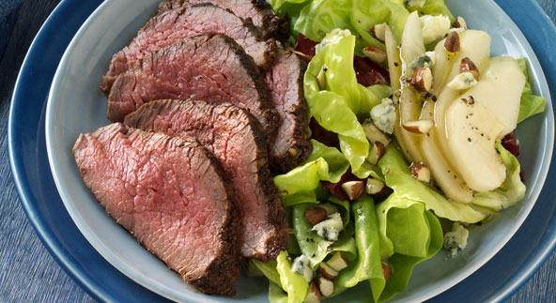
Spiced Tri-Tip Roast with Pear, Radicchio, and Blue Cheese Salad

Paste
3 tablespoons extra-virgin olive oil
1 tablespoon fresh lemon juice
1 tablespoon ground cumin
1 tablespoon paprika
2 teaspoons kosher salt
1 teaspoon ground allspice
1 teaspoon freshly ground black pepper
1 tri-tip roast (also called triangular roast)
or boneless strip loin roast, about
2 pounds and 1-1/2 to
2 inches thick, well trimmed

Salad
2 tablespoons balsamic vinegar
6 tablespoons extra-virgin olive oil
1 teaspoon kosher salt
1/2 teaspoon freshly ground black pepper
1 small head radicchio, torn into bite-sized pieces (about 4 cups)
1/2 large head butter lettuce, torn into bite-sized pieces (about 4 cups)
2 large pears, such as Bosc, peeled (if desired), cut lengthwise into 1/4-inch-thick slices
3–4 ounces coarsely crumbled blue cheese, such as Maytag (3/4 to 1 cup)
1/2 cup whole almonds with skin, toasted and roughly chopped or 1/2 cup hazelnuts, toasted, skinned, and roughly chopped

Instructions

In a small bowl whisk the paste ingredients. Smear the paste evenly over all sides of the roast. Let the roast marinate at room temperature for 1 hour.

Prepare the grill for direct and indirect cooking over medium heat (350° to 450°F).

Brush the cooking grates clean. Grill the roast over direct medium heat, with the lid closed as much as possible, until well marked on both sides, 8 to 10 minutes, turning once. Move the roast over indirect medium heat and continue to cook to your desired doneness, 15 to 20 minutes more for medium rare. Remove from the grill and let rest for 3 to 5 minutes. Cut the meat across the grain into very thin slices.

While the roast is cooking, make the salad: In a small bowl whisk the vinegar, oil, salt, and pepper. In a large bowl combine the radicchio and butter lettuce. Add half of the dressing and toss to coat.

Divide the salad among four plates. Top each salad with pear slices, blue cheese, and almonds. Drizzle the remaining dressing over each salad. Serve immediately with the meat alongside.

