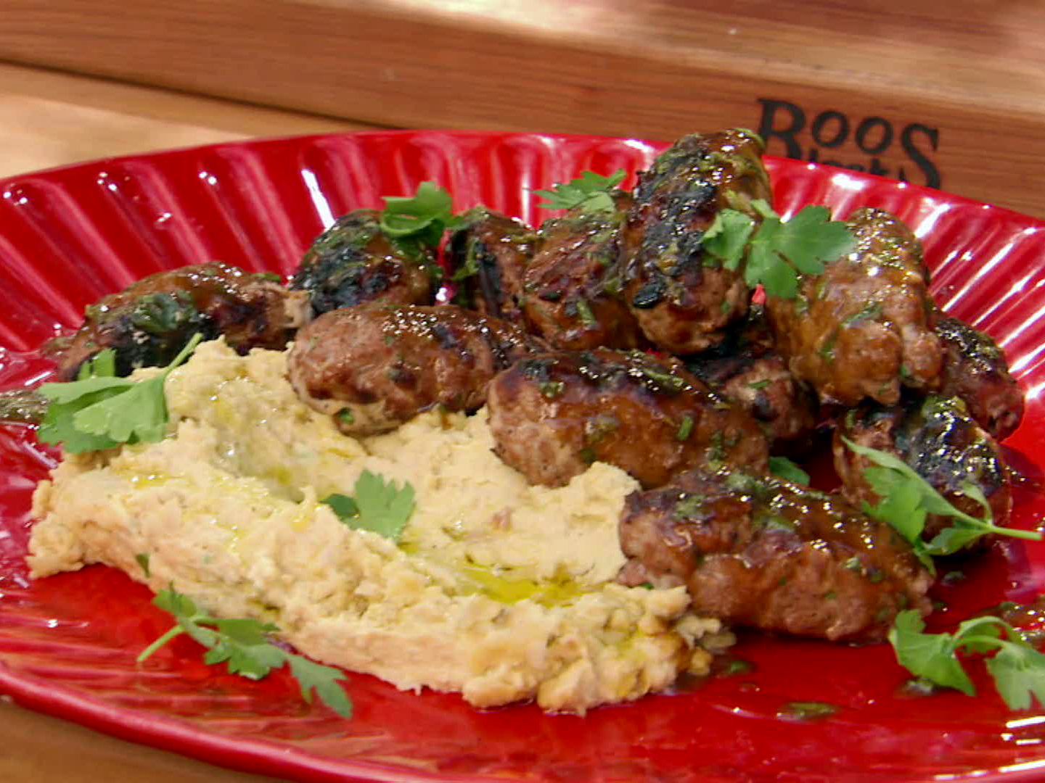
Tuna Koftes

Pomegranate Molasses-Mint Glaze:
1/2 cup pomegranate molasses
or reduced pomegranate juice
1 tablespoon clover honey
2 teaspoons fresh lemon juice
2 teaspoons Dijon mustard
8 fresh mint leaves, finely chopped
Kosher salt and freshly
ground black pepper

Kofte:
5 tablespoons canola oil
1 small red onion, finely diced
2 cloves garlic, smashed to a paste
3 tablespoons tomato paste
1 teaspoon ground cumin
1/2 teaspoon ground allspice
1/2 teaspoon ground cinnamon
1/8 teaspoon cayenne pepper
1 1/2 pounds fresh tuna
1/4 cup chopped fresh flat-leaf parsley, plus whole leaves for serving
Zest of 1 lemon
Kosher salt and freshly ground black pepper

Hummus and flat bread for serving.

For the glaze: Whisk together the pomegranate molasses, honey, lemon juice, mustard and mint and season with salt and pepper. Let the glaze sit at room temperature for at least 30 minutes.

For the kofte: Heat 2 tablespoons canola oil in a small saute pan over high heat. Add the onions and cook until soft, about 4 minutes. Add the garlic and cook for 30 seconds. Add the tomato paste, cumin, allspice and cayenne, and cook 1 minute more. Remove from the heat and let cool slightly.

(Hand chop the tuna ... or use the food processor as instructed below, but don't over-process the tuna as the consistency can become a little pasty.) Cut the tuna into large chunks and add it to a food processor along with the cooled spice mixture, the 1/4 cup chopped parsley and lemon zest. Season with salt and pepper. Process until fairly smooth. Transfer to a bowl and chill for at least 1 hour.

Preheat a charcoal grill to high heat using the direct heat method.

Divide the tuna mixture into 12 equal portions and form into patties. Brush the koftes with some of the remaining oil and sprinkle with salt and pepper. Grill until golden brown and slightly charred on all sides and just cooked through, about 2 minutes per side. Reserve some of the glaze for serving, and then brush the koftes with some of the remaining glaze each time you turn.

Drizzle the patties with more glaze and scatter the parsley leaves over the top. Serve with hummus and flat bread.

