Secret Ingredient Biscuits

Why this recipe works:
The secret ingredient in these biscuits, also called mystery biscuits, is mayonnaise. It may sound odd, but just like the shortening, butter, or cream in more traditional recipes, the mayonnaise provides the fat in these biscuits. The emulsification of oil and egg yolks in mayo makes for incredibly tender biscuits, and the dough comes together with just a stir. The salt and vinegar in the mayonnaise mean that these biscuits are well seasoned and just a touch savory, and the simple drop method makes them some of the easiest biscuits we’ve ever made.

Makes 12 biscuits
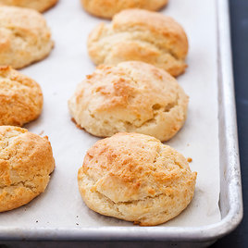
These biscuits are best with whole milk, but the recipe will work with reduced-fat milk. Don’t use nonfat. Reduced-fat mayonnaise can be used, but the biscuits will be less tender and flavorful. Don’t use fat-free mayonnaise.

Ingredients

2 cups (10 ounces) all-purpose flour
1 tablespoon sugar
2 teaspoons baking powder
1/2 teaspoon baking soda
3/4 teaspoon salt
1 cup whole milk
3/4 cup mayonnaise

Instructions

1. Adjust oven rack to middle position and heat oven to 450 degrees. Line rimmed baking sheet with parchment paper. Combine flour, sugar, baking powder, baking soda, and salt in large bowl. Whisk milk and mayonnaise together in separate bowl. Stir milk mixture into flour mixture until just combined.

2. Using greased 1/4-cup measure, drop 12 level scoops of dough onto prepared sheet, spacing them 1 1/2 inches apart. Use small spoon, if necessary, to dislodge dough from measure. (This dough is sticky, and you may have to regrease your measure several times during portioning.) Bake until biscuit tops are golden brown, 12 to 14 minutes, rotating sheet halfway through baking. Transfer biscuits to wire rack and let cool for 5 minutes. Serve.

You Put What in Your Biscuits?

You’ve probably heard of biscuits made with butter, with cream, and with lard. But have you ever tasted a biscuit made with mayonnaise? Granted, they sound pretty weird. But think about it: Mayonnaise is primarily an emulsification of oil and egg yolk, and these are fats that can make very tender biscuits. Plus the savory quality of mayonnaise comes through in these biscuits, making them perfect for eating with dinner.

