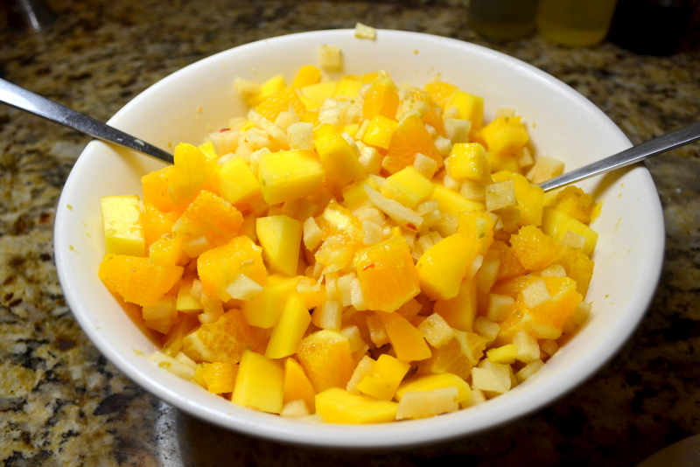
Mango-Orange-Jicama Salad
3 tablespoons sugar
1/4 teaspoon grated lime zest plus 3 tablespoons
juice (2 limes)
1/4 teaspoon red pepper flakes
Pinch salt
12 ounces jícama
2 mangos
2 oranges

- Peel the jícama, and cut into 1/4″ dice (should yield 1-1/2 cups).
- In small saucepan, add the 3 tablespoons sugar, lime zest and juice, 1/4 teaspoon red pepper flakes, a pinch salt. Put over medium burner and cook for 1 to 2 minutes until the sugar dissolves; stirring constantly. Remove pan from burner, stir in jícama to coat, and allow the syrup to cool for 20 minutes.
- Meanwhile, peel the mangos, removing pit, and cut into 1/2″ dice (should yield about 4 cups). Add to a large serving bowl. Peel your oranges and cut away the pith. Slice into 1/2″ thick rounds and then into 1/2″ dice. Add to bowl with diced mango.
- After the syrup has cooled for 20 minutes, pour over fruit in serving bowl and toss until well combined. Cover and refrigerate for 15 minutes prior to serving.

