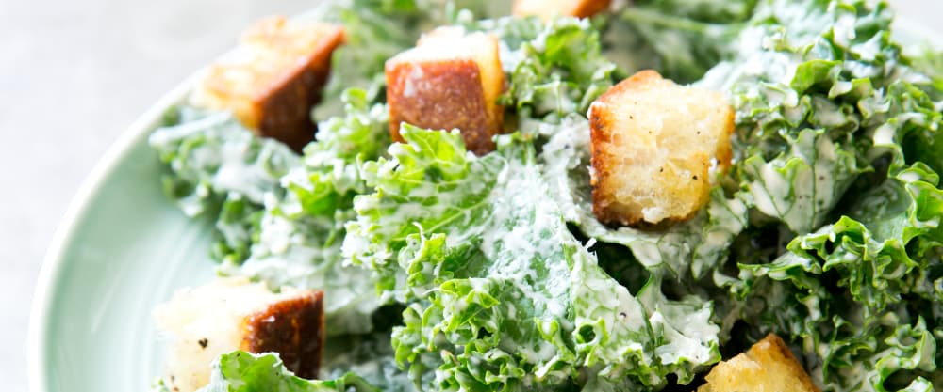
Kale-Caesar Salad [ATK]

Kale offers the make-ahead cook a great option for a salad. Because kale is notoriously tough and fibrous, it actually benefits from being prepared ahead. In fact it may be the only leafy green salad you can dress hours in advance. In order to soften the leaves and make them more palatable, we soaked them in a warm water bath for 10 minutes. Next we tossed the kale with the Caesar salad dressing, letting it marinate in the refrigerator for at least 20 minutes; this gave the salad time to cool back down and allowed the flavors to meld together. To balance the strong flavor of kale, our dressing is extra-potent, with extra Worcestershire sauce and a splash of white wine vinegar and Dijon mustard for kick.

The kale leaves must be dressed at least 20 minutes (or up to 6 hours) before serving. We like to use curly kale in this salad because its curly edges help to hold on to the dressing.

Salad
12 ounces curly kale, stemmed and cut into 1-inch pieces (16 cups)
1 ounce Parmesan cheese, grated (½ cup)
1 recipe Croutons for Caesar Salad (see recipe below)

Dressing
½ cup mayonnaise
¼ cup grated Parmesan cheese
2 tablespoons lemon juice
1 tablespoon white wine vinegar
1 tablespoon Worcestershire sauce
1 tablespoon Dijon mustard
3 anchovy fillets, rinsed
1 garlic clove, minced
½ teaspoon salt
½ teaspoon pepper
¼ cup extra-virgin olive oil

1. For the salad: Place kale in large bowl and cover with warm tap water (110 to 115 degrees). Swish kale around to remove grit. Let kale sit in warm water bath for 10 minutes. Remove kale from water and spin dry in salad spinner in multiple batches. Pat leaves dry with paper towels if still wet.

2. For the dressing: Process mayonnaise, Parmesan, lemon juice, vinegar, Worcestershire, mustard, anchovies, garlic, salt, and pepper in blender until pureed, about 30 seconds. With blender running, slowly add oil until emulsified.

3. Toss kale with ¾ cup dressing in large bowl. Refrigerate dressed kale for 20 minutes.

4. Toss Parmesan and croutons with dressed kale. Serve, passing remaining ¼ cup dressing at table.

To Make Ahead: Dressed kale and remaining ¼ cup dressing, prepared through step 3, can be refrigerated separately for up to 6 hours. To serve, whisk dressing to loosen and continue with step 4.

Croutons for Caesar Salad

3 ounces baguette, cut into ¾-inch cubes (3 cups)
2 tablespoons extra-virgin olive oil
¼ teaspoon pepper
1/8 teaspoon salt

Adjust oven rack to middle position and heat oven to 350 degrees. Toss all ingredients together in bowl. Bake on rimmed baking sheet until golden and crisp, about 15 minutes. Let croutons cool completely on sheet. Serve.

To Make Ahead: Croutons can be stored at room temperature for up to 24 hour

