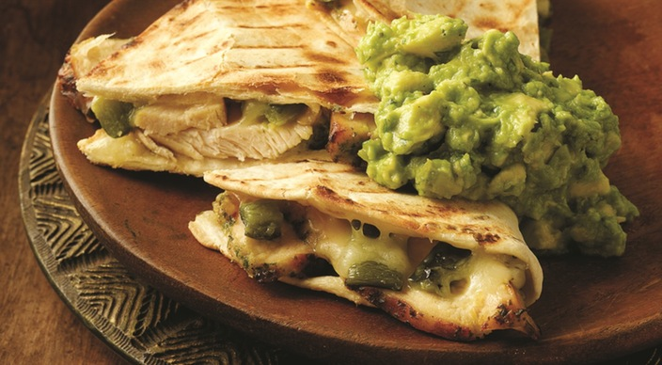
Chicken Poblano Quesadillas

PASTE
2 large garlic cloves
1 jalapeño chile pepper, stem removed
1 cup tightly packed fresh basil leaves
3 tablespoons extra virgin olive oil
2 tablespoons tequila
1 teaspoon kosher salt
½ teaspoon freshly ground black pepper
2 boneless, skinless chicken breast halves, each about 6 ounces

GUACAMOLE
2 Hass avocados, pitted and skins removed
1 tablespoon fresh lime juice
2 medium garlic cloves
¼ teaspoon kosher salt
1 tablespoon finely chopped fresh cilantro
⅛ teaspoon freshly ground black pepper

AND
2 medium poblano chile peppers, stems removed
4 flour tortillas (10 inches)
2 cups grated Monterey Jack cheese

INSTRUCTIONS

In a food processor mince the garlic and jalapeño. Add the remaining paste ingredients and process until smooth. Spread the paste on all sides of the chicken breasts. Cover and refrigerate for 3 to 4 hours.

In a medium bowl mash the avocados with the back of a fork and immediately mix in the lime juice. Roughly chop the garlic, then sprinkle the salt over the garlic and, using the side of a knife, crush the garlic with the salt until you create a smooth paste. Add the garlic mixture, cilantro, and pepper to the bowl. Mix well.

Prepare the grill for direct cooking over medium heat (350° to 450°F).

Grill the chicken over direct medium heat, with the lid closed, until the juices run clear and the meat is opaque in the center, 8 to 12 minutes, turning once. At the same time, grill the poblano chiles over direct medium heat until evenly charred on all sides, 7 to 9 minutes, turning as needed. Remove from the grill and allow to cool. Cut the chicken into thin slices. Peel away the charred skins from the chiles and roughly chop the flesh.

Lay the tortillas in a single layer on a work surface. Evenly divide the chicken, chiles, and cheese over half of each tortilla. Fold the empty half of each tortilla over the filling, creating a half circle, and press down firmly. Grill the quesadillas over direct medium heat, with the lid closed, until well marked and the cheese is melted, 4 to 6 minutes, turning once. Allow the quesadillas to cool for a minute or two before cutting into wedges. Serve warm with the guacamole spooned on the top of each wedge.

