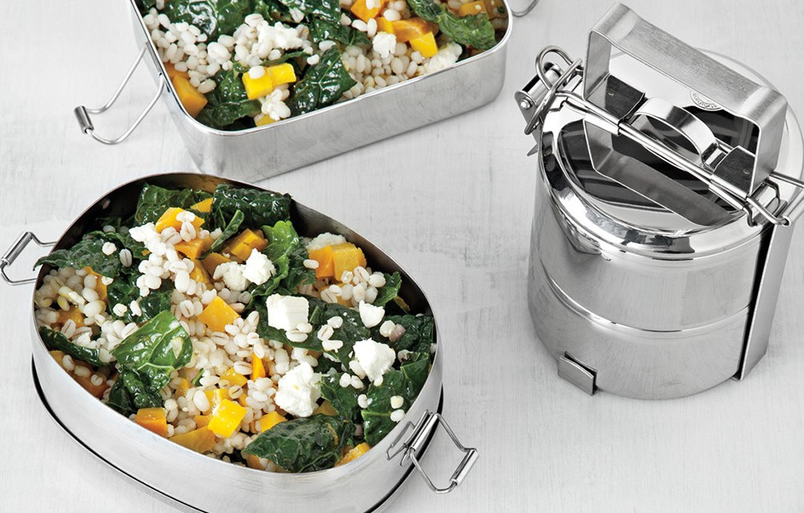
Kale/Barley Salad

1/4 cup plus 2 Tbsp. extra-virgin olive oil; more for drizzling
2 tablespoons white wine vinegar
2 tablespoons (packed) light brown sugar
1/2 teaspoon Ǽinely grated orange zest
Kosher salt, freshly ground pepper
1 bunch Tuscan kale, center ribs and stems removed, leaves cut into 1-inch squares
1/4 cup minced shallots
3 medium golden beets (about 1 bunch), trimmed
1 1/4 cups pearl barley
4 ounces feta, crumbled
2 teaspoons (or more) unseasoned rice vinegar

INGREDIENT INFO
Tuscan kale, also called black kale, dinosaur kale, Lacinato kale, or cavolo nero, has long, narrow, very dark green bumpy leaves and is available at farmers' markets and some supermarkets.

INSTRUCTIONS
Whisk 1/4 cup oil, white wine vinegar, sugar, and orange zest in a large bowl to blend; season with salt and pepper. Add kale and shallots; mix until completely coated. Cover and chill until kale is tender, at least 3 hours.

Meanwhile, preheat oven to 375°. Arrange beets in a small baking dish and drizzle with a little oil. Season with salt and turn beets to coat. Cover with foil. Bake beets until tender when pierced with a thin knife, about 45 minutes. Let cool completely. Peel beets. Cut into 1/4-inch pieces (you should have about 2 cups).

Cook barley in a large pot of boiling salted water until just tender, about 45 minutes. Drain barley and spread out on a rimmed baking sheet; let cool completely.

Add beets, barley, and feta to kale. Drizzle salad with remaining 2 tablespoons oil and 2 tablespoons rice vinegar; fold gently to combine. Season to taste with pepper and more rice vinegar, if desired

Salad can be made 2 days ahead. Cover and chill.

