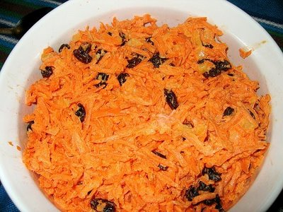
Carrot/Raisin Salad

1/2 cup sour cream
1/2 cup light mayonnaise
1 tablespoon lemon juice
1/2 teaspoon salt
1 tablespoon brown sugar
4 cups shredded carrot
1 cup raisins

In a large bowl, whisk together the sour cream, mayonnaise, lemon juice, salt and brown sugar. Add carrots and raisins and stir until coated.

