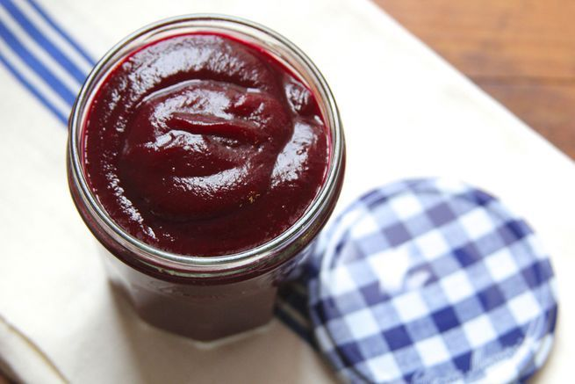
Beet Ketchup

1 lb. cooked red beets, diced
1 cup apple cider vinegar
1⁄2 cup brown sugar
1⁄4 cup diced onion
1⁄2 tsp. salt
1⁄4 tsp. ground coriander
1⁄4 tsp. ground cloves
Freshly ground black pepper, to taste

Combine the chopped beets, vinegar, brown sugar, and onion in a 6-qt. saucepan and stir to combine. Place over high heat and bring to a boil. Reduce the heat to medium-high and cook for 25 minutes, until beets are tender.

Remove saucepan from heat and purée with remaining ingredients. Taste and adjust seasoning, if necessary.

