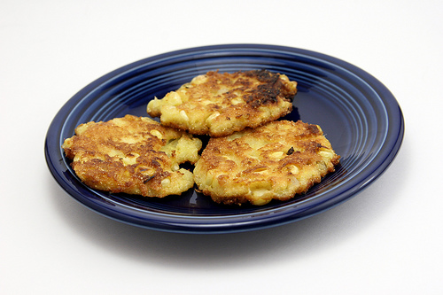
ATK Corn Fritters

3-4 medium ears fresh corn, husks and silk removed
1 large egg, beaten lightly
3 Tablespoons all-purpose flour
3 Tablespoons cornmeal
2 Tablespoons heavy cream
1 large shallot, minced (about 3 Tablespoons)
3/4 teaspoon salt
Pinch cayenne pepper
1/4 cup vegetable or corn oil, or more as needed

Chipotle Mayo, for serving

Using a chef's knife, cut the kernels from 1 or 2 ears of corn (to make this easier, cut the ear of corn in half, then rest cut side on cutting board). You should have about 1 cup. Transfer the kernels to a medium bowl.

Grate the kernels from the remaining corn on hte large holes of a box grater, then firmly scrape any pulp remaining on the cob with the back of a knife. You should have a generous 1/2 cup kernels and pulp. Transfer the grated kernels and pulp to the bowl with the cut kernels.

Mix the egg, flour, cornmeal, cream, shallot, salt, and cayenne into the corn mixture to form a thick batter. (The batter can be covered and refrigerated for up to 4 hours.)

Heat the oil in a 12-inch heavy-bottomed skillet over medium-high heat until shimmering, about 2 minutes. Drop heaping tablespoonfuls of batter into the oil (half the batter, or 6 fritters, should fit into the skillet at once). Fry until golden brown, about 50 seconds, then, using a thin metal spatula, turn the fritters and fry until the second side is golden brown, about 50 seconds longer.

Transfer the fritters to a paper towel-lined plate. Add more oil to the skillet if necessary and heat until shimmering. Repeat to fry the remaining batter. Serve the fritters immediately.

Serve with Chipotle Mayo.

