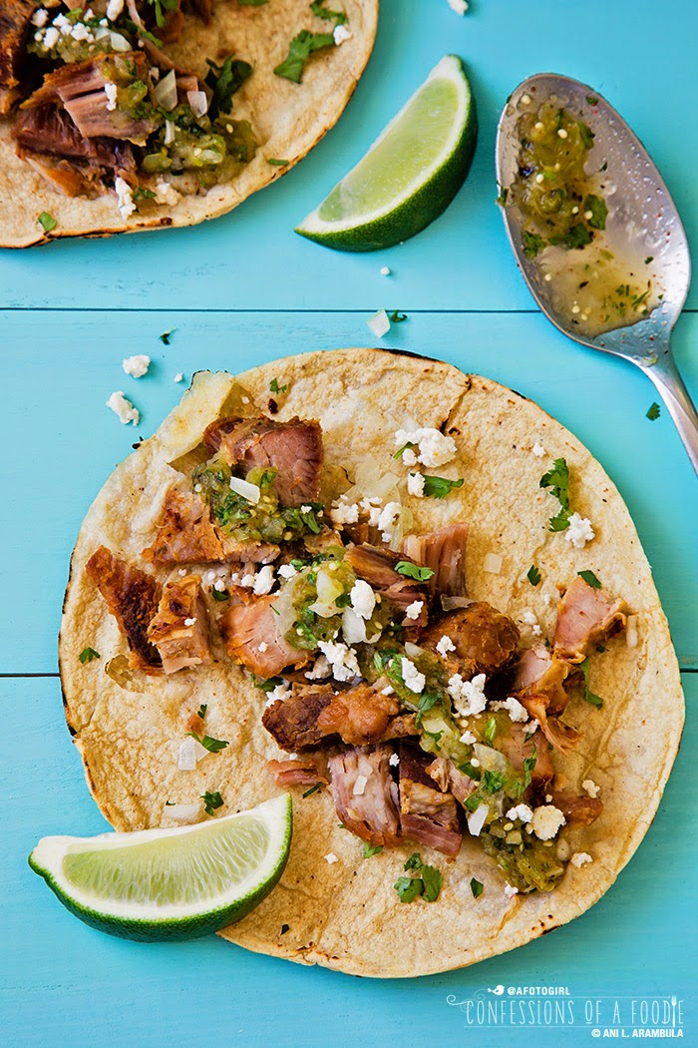
Real Carnitas

2 pounds pork butt
2 pounds pork lard
1 cup water
2 medium oranges, washed and halved
4 cloves garlic, peeled
½ medium onion, peeled
1 large stick Mexican cinnamon stick or 2 small regular cinnamon sticks
4 bay leaves
2 tablespoons kosher salt
1 tablespoon dried whole Mexican oregano, crushed between palms
1 teaspoon dried thyme
1 cup evaporated milk
½ cup beer (nothing too hoppy)
16 corn tortillas

For Garnish:
Lime wedges
Chopped onions
Chopped cilantro
Salsa
Queso fresco

1. Trim excess fat from pork butt then cut into 3 inch chunks. Set aside.

2. Add lard and water to a cold stock pot or dutch oven. Turn heat to medium high. Once lard has liquified, carefully add meat.

3. Squeeze the juice from the oranges directly into the pot of meat; add the spent oranges to the pot.

4. Simmer on medium, uncovered, for one hour. Stir the meat every 15 minutes to ensure it doesn't stick to the bottom of the pot.

5. Add the garlic, onion, cinnamon, bay leaves, salt, oregano, thyme, milk and beer to the pot. Stir well to combine. Continue simmering on medium heat, uncovered, for an additional hour. Stir meat at least every 20 minutes to make sure it's cooking evenly.

6. Use a slotted spoon to remove meat to a strainer, then place on a paper towel-lined plate to cool enough to handle.

7. Once cool enough to handle, rough chop meat.

8. Warm tortillas, fill with meat then add a squeeze of lime over the meat. Add optional garnishes.

