Ropa Vieja, which means "old clothes" in Spanish, is one of Cuba's national dishes but is claimed by other cultures as well. The stewed meat can also be found in Puerto Rico and the Canary Islands, and the dish dates back to the 12th century via Sephardic Jews from Spain. Serve this America's Test Kitchen recipe with rice and beans or fried sweet plantains.
Cuban Braised Shredded Beef (Ropa Vieja)
Serves 6 to 8
Look for a brisket that is 1 1/2 to 2 1/2 inches thick.
1 (2-pound) beef brisket, fat trimmed to 1/4 inch
Salt and pepper
5 tablespoons vegetable oil
2 onions, halved and sliced thin
2 red bell peppers, stemmed, seeded, and sliced into 1/4-inch-wide strips
2 anchovy fillets, rinsed, patted dry, and minced
4 garlic cloves, minced
2 teaspoons ground cumin
1 1/2 teaspoons dried oregano
1/2 cup dry white wine
2 cups chicken broth
1 (8-ounce) can tomato sauce
2 bay leaves
3/4 cup pitted green olives, chopped coarse
3/4 teaspoon white wine vinegar, plus extra for seasoning

Adjust oven rack to middle position and heat oven to 300 degrees.
Cut brisket against grain into 2-inch-wide strips. Cut any strips longer than 5 inches in half crosswise. Season beef on all sides with salt and pepper. Heat 4 tablespoons oil in Dutch oven over medium-high heat until just smoking. Brown beef on all sides, 7 to 10 minutes; transfer to large plate and set aside.

Add onions and bell peppers and cook until softened and pan bottom develops fond, 10 to 15 minutes. Transfer vegetables to bowl and set aside. Add remaining 1 tablespoon oil to now-empty pot, then add anchovies, garlic, cumin, and oregano and cook until fragrant, about 30 seconds. Stir in wine, scraping up any browned bits, and cook until mostly evaporated, about 1 minute. Stir in broth, tomato sauce, and bay leaves.

Return beef and any accumulated juices to pot and bring to simmer over high heat. Transfer to oven and cook, covered, until beef is just tender, 2 to 2 1/4 hours, flipping meat halfway through cooking.

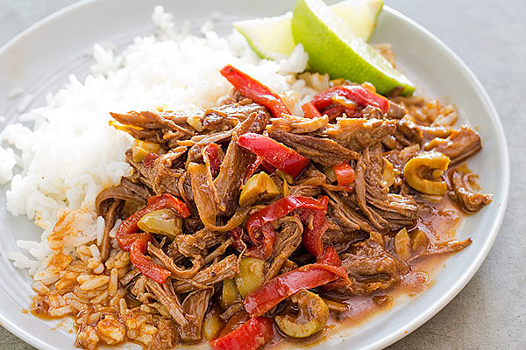
Transfer beef to cutting board. Remove and discard bay leaves. When beef is cool enough to handle, shred into 1/4-inch-thick pieces. Meanwhile, add olives and reserved vegetables to pot and bring to boil over medium-high heat; simmer until thickened and measures 4 cups, 5 to 7 minutes. Stir in beef. Add vinegar. Season with salt, pepper, and extra vinegar to taste; serve.

