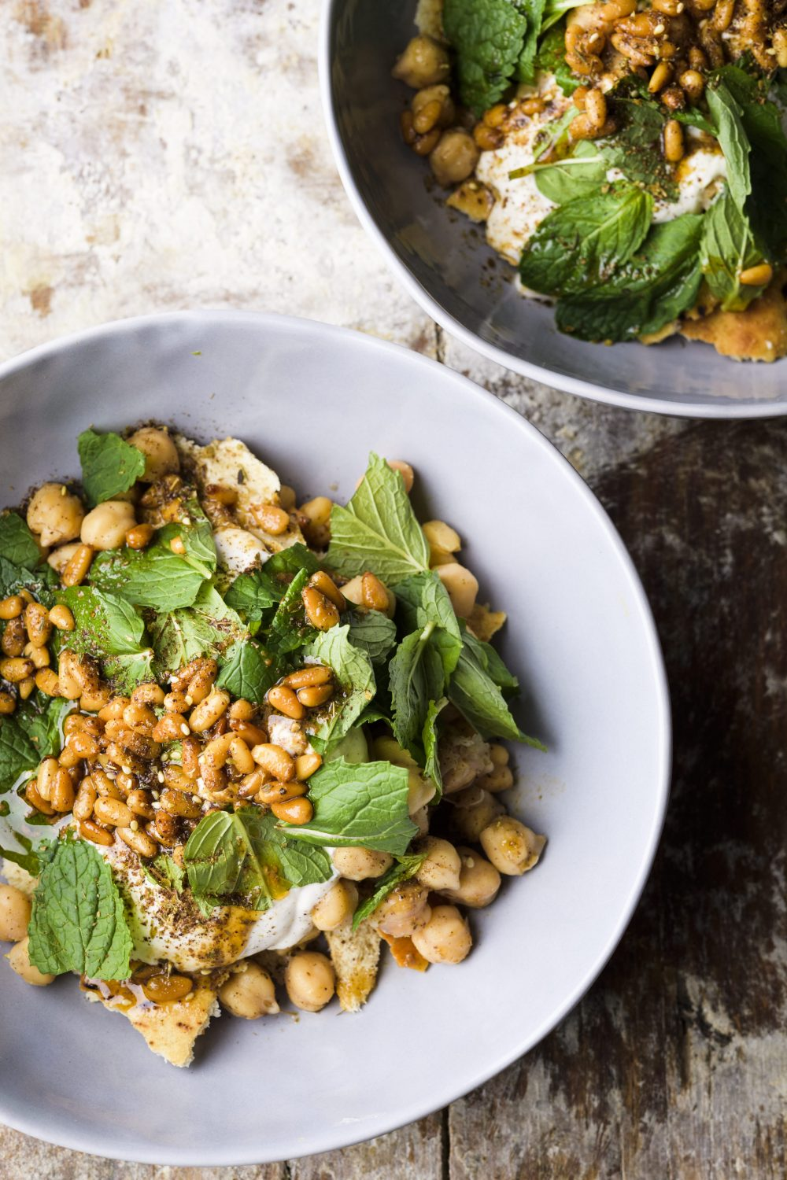
Fatteh
1 cup plain whole-milk yogurt
1/4 cup tahini
2 medium garlic cloves, finely grated
1 teaspoon grated lemon zest, plus 1 tablespoon lemon juice
Kosher salt and ground black pepper
2 8-inch pita breads, each split into 2 rounds
2 1/2 teaspoons ground cumin, divided
5 tablespoons salted butter, melted, divided
1/4 cup pine nuts
1/8 - 1/4 teaspoon cayenne pepper (optional)
2 15½-ounce cans chickpeas, rinsed and drained
1 1/2 teaspoons za'atar, plus more to serve (optional)
1 1/2 cups lightly packed fresh mint, torn if large

Heat the oven to 400°F with a rack in the middle position. In a small bowl, whisk together the yogurt, tahini, garlic, lemon zest and juice, ½ teaspoon salt and ¼ teaspoon black pepper. Set aside.

Arrange the pita on a rimmed baking sheet. Use 2 tablespoons of the butter to brush both sides of each round, then sprinkle evenly with 2 teaspoons of the cumin. Bake for 5 minutes, then flip each round and continue to bake until browned and crisp, 5 to 6 minutes. Transfer to a wire rack and let cool; reserve the baking sheet.

While the pita cools, distribute the pine nuts on the reserved baking sheet and toast until golden brown, 3 to 5 minutes, stirring once about halfway through. Immediately transfer to a small bowl and toss with the remaining 3 tablespoons butter, the remaining ½ teaspoon cumin, cayenne (if using) and ¼ teaspoon each salt and black pepper. Set aside.

In a medium microwave-safe bowl, toss the chickpeas with the za'atar (if using), 1 teaspoon salt and 3 tablespoons water. Cover and microwave on high until hot, 3 to 3½ minutes, stirring once halfway through. Meanwhile, break the pita into bite-size pieces and place in a wide, shallow serving bowl or divide among 4 individual bowls.

Using a slotted spoon, arrange the warmed chickpeas over the pita. Spoon on the yogurt mixture, top with mint and spoon on the pine nut–butter mixture. Sprinkle with with additional za'atar (if using).

Tip: Don't cut back on the butter that's tossed with the toasted pine nuts. It may seem like a lot, but the butter adds a sweetness that balances the tang of the yogurt and makes the dish taste full and deep.

