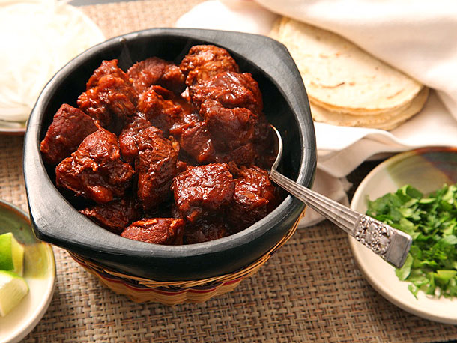
Braised New Mexico-Style Pork in Red Chile Sauce (Carne Adovada)
Serves 6
Pork butt roast is often labeled Boston butt. For an accurate measurement of boiling water, bring a full kettle of water to a boil and then measure out the desired amount. If you can't find New Mexican chiles, substitute dried California chiles. Dried chiles should be pliable and smell slightly fruity. Kitchen shears can be used to cut them. If you can't find Mexican oregano, substitute Mediterranean oregano. Letting the stew rest for 10 minutes before serving allows the sauce to thicken and better coat the meat. Serve with rice and beans, crispy potatoes, or flour tortillas with shredded lettuce and chopped tomato, or shred the pork as a filling for tacos and burritos.
Ingredients
- 1 (3½- to 4-pound) boneless pork butt roast, trimmed and cut into 1½-inch pieces
- Kosher salt
- 4 ounces dried New Mexican chiles, wiped clean, stemmed, seeded, and torn into 1-inch pieces
- 4 cups boiling water
- 2 tablespoons honey
- 2 tablespoons distilled white vinegar
- 5 garlic cloves, peeled
- 2 teaspoons dried Mexican oregano
- 2 teaspoon ground cumin
- ½ teaspoon cayenne pepper
- ⅛ teaspoon ground cloves
To Prepare
Toss pork and 1 tablespoon salt together in bowl; refrigerate for 1 hour.
Place chiles in medium bowl. Pour boiling water over chiles, making sure they are completely submerged, and let stand until softened, 30 minutes. Adjust oven rack to lower-middle position and heat oven to 325 degrees.
Drain chiles and reserve 2 cups soaking liquid (discard remaining liquid). Process chiles, honey, vinegar, garlic, oregano, cumin, cayenne, cloves, and 1 teaspoon salt in blender until chiles are finely ground and thick paste forms, about 30 seconds. With blender running, add 1 cup reserved liquid and process until smooth, 1½ to 2 minutes, adding up to ¼ cup additional reserved liquid to maintain vortex. Add remaining reserved liquid and continue to blend sauce at high speed, 1 minute longer.
Combine pork and chile sauce in Dutch oven, stirring to make sure pork is evenly coated. Bring to boil over high heat. Cover pot, transfer to oven, and cook until pork is tender and fork inserted into pork meets little to no resistance, 2 to 2½ hours.
Using wooden spoon, scrape any browned bits from sides of pot and stir until pork and sauce are recombined and sauce is smooth and homogeneous. Let stand, uncovered, for 10 minutes. Season with salt to taste. Serve with lime wedges. (Leftover pork can be refrigerated for up to 3 days.)

