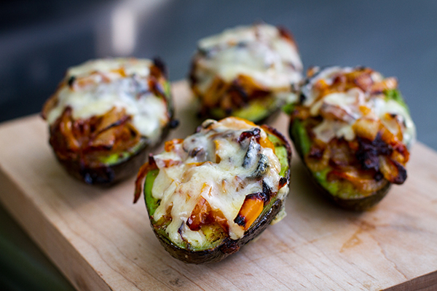
Grilled and Stuffed Avocados

Ingredients

(Serrano?)
(Crumbled Bacon?)

1 Tablespoon Extra Virgin Olive Oil
1 Tablespoon Unsalted Butter
1 small onion, sliced
1 small bell pepper, sliced
2 Avocados, ripe, slightly soft to the touch
1 teaspoon cumin
½ teaspoon kosher salt
¼ teaspoon freshly cracked pepper
4 ¼ inch slices of mature cheddar cheese (or extra sharp cheddar)

Instructions
Thinly slice the onions and peppers.

In a small skillet over low heat, add the butter and olive oil. Once the butter has melted, add the onion and pepper. Cook for approximately 20-25 minutes, stirring periodically.

Pit the Avocados.

Mix together the cumin, salt, and pepper. Sprinkle evenly over the avocado flesh.

Add equal amounts of the onion/pepper mixture to the tops of the 4 avocados halves.

Grill the avocados over direct medium heat with the lid closed for approximately 20-25 minutes, until the avocado is soft when pressed.

Add the cheese to each avocado, close the lid, and grill for another 5 minutes, or until the cheese has melted. Remove and serve.

