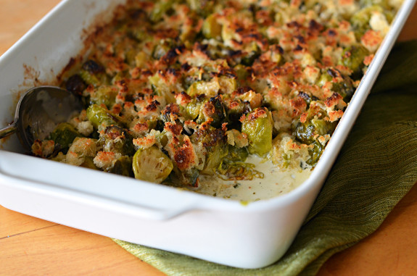
WHY THIS RECIPE WORKS:
In developing a Brussels sprout gratin, we wanted to make a dish that highlighted the earthy flavor of Brussels sprouts. Preroasting the sprouts makes them rich and nutty, not cabbagey. We make a quick, creamy Mornay sauce, using a combination of Gruyere and Parmesan cheeses, to bind the gratin. To add crunch, we top the gratin with pretoasted panko bread crumbs and more nutty Gruyere.

Look for smaller Brussels sprouts, no bigger than a golf ball, as they’re likely to be sweeter and more tender than large sprouts. If you can find only large sprouts, quarter them. A broiler-safe dish is important because the sprouts cook at such a high temperature.

2 1/2 pounds Brussels sprouts, trimmed and halved through stem
1 tablespoon vegetable oil
Salt and pepper
3 tablespoons unsalted butter
1/4 cup panko bread crumbs
1 shallot, minced
1 garlic clove, minced
1 tablespoon all-purpose flour
1 1/4 cups heavy cream
3/4 cup chicken broth
2 ounces Gruyère cheese, shredded (1/2 cup)
1 ounce Parmesan cheese, grated (1/2 cup)
Pinch ground nutmeg
Pinch cayenne pepper

1. Adjust oven rack to middle position and heat oven to 450 degrees. Grease 13 by 9-inch broiler-safe baking dish. Toss Brussels sprouts, oil, 1/2 teaspoon salt, and 1/4 teaspoon pepper together in prepared baking dish. Bake until sprouts are well browned and tender, 30 to 35 minutes. Transfer to wire rack and set aside to cool for at least 5 minutes or up to 30 minutes.

2. Meanwhile, melt 1 tablespoon butter in medium saucepan over medium heat. Add panko and cook, stirring frequently, until golden brown, about 3 minutes. Transfer to bowl and stir in 1/4 teaspoon salt and 1/4 teaspoon pepper; set aside. Wipe saucepan clean with paper towels.

3. Melt remaining 2 tablespoons butter in now-empty saucepan over medium heat. Add shallot and garlic and cook until just softened, about 1 minute. Stir in flour and cook for 1 minute. Whisk in cream and broth and bring to boil over medium-high heat. Once boiling, remove from heat and whisk in 1/4 cup Gruyère, Parmesan, nutmeg, cayenne, 1/4 teaspoon pepper, and 1/8 teaspoon salt until smooth.

4. Pour cream mixture over Brussels sprouts in baking dish and stir to combine. Sprinkle evenly with panko mixture and remaining 1/4 cup Gruyère. Bake until bubbling around edges and golden brown on top, 5 to 7 minutes. Transfer dish to wire rack and let cool for 10 minutes. Serve.

