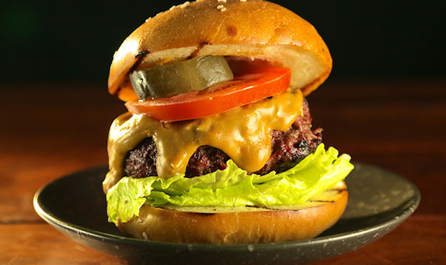
Raichlen Smoked Burgers

1 1/2 pounds ground chuck, well chilled
1 1/2 pounds ground sirloin, well chilled
Coarse salt (kosher or sea) and freshly ground black pepper
3 tablespoons butter, melted
8 hamburger buns, split
Rauchbier (“Smoked Beer”) Cheese Sauce

Toppings (any or all):
Lettuce leaves
Sliced ripe tomatoes
Sliced dill pickles or sweet pickles
Grilled bacon
Sliced onions
Ketchup
Mustard
Mayonnaise

Step 1: Place the ground beef in a mixing bowl. Working with a light touch, combine the meats, then form patties 4 inches in diameter and 1 inch thick. Season generously with salt and pepper.

Step 2: Arrange the burgers on a wire rack over a pan of ice. Make the Rauchbier Cheese Sauce and keep warm.

Step 3: On a charcoal smoker or grill: Place a small mound of charcoal in the firebox (or to one side of a kettle grill) and light it. When the coals glow red, place the burgers on their rack over ice in the smoke chamber (as far away as possible from the fire). Toss the hay on the coals and cover the smoker. Smoke the burgers until bronzed with smoke: this will take 2 to 3 minutes. You can smoke the burgers several hours ahead, but keep refrigerated.

On a gas grill: Light one side of the grill on high. Place the burgers on their rack over ice on the opposite side of the grill. Place the hay over the lit burner and close the grill lid. Smoke the burgers until bronzed with smoke: this will take 2 to 3 minutes. You can smoke the burgers several hours ahead, but keep refrigerated.

Step 4: Set up your grill for direct grilling and preheat to high. Brush and oil the grill grate. Direct grill the burgers until cooked to at least 160 degrees, about 4 minutes per side.

Step 5: Brush the buns with melted butter and toast them, cut sides down, on the grill, 1 minute.

Step 6: Place the burgers on the buns, adding your favorite toppings and condiments. A lettuce leaf under the burger, for example, prevents the bun from getting soggy.

