This is a sketch of a sandwich from the Unique Eats show … Kickshaw Grilled Cheese in Queens, NY
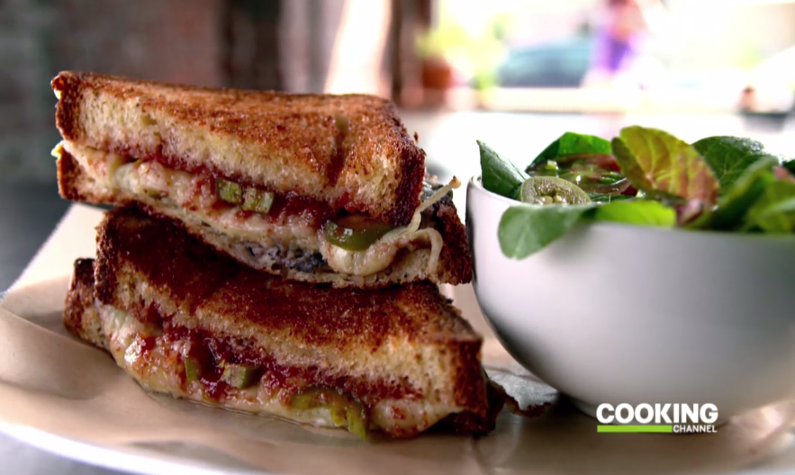
1 can black beans, drained and rinsed
5 garlic cloves, peeled
2 tbs ground cumin
Olive Oil

Guava jelly (or Apricot jelly)
Pickled jalapenos
12 ounces Gouda cheese, shredded

Homemade Sandwich bread

Butter

Black Bean Hummus:
Process beans, garlic, and cumin in food processor while drizzling in olive oil.

Spread black bean hummus on one slice of bread. Spread jelly on the other slice of bread. Top the jelly with several jalapenos. Top the prepared sides of bread with gouda cheese. Melt, open-faced, in a 400F degree oven.

Fold the sandwich halves together. Butter the outside of the sandwich and grill until nicely crisped in a hot skillet.

