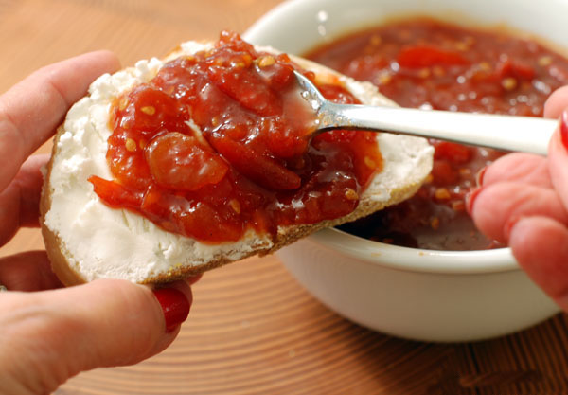
TOMATO JAM:

2 tablespoons canola oil
1 pound ripe plum tomatoes, roughly chopped
2 tablespoons granulated sugar
2 tablespoons red wine vinegar
1 teaspoon kosher salt
1/2 teaspoon ground coriander

1/4 teaspoon freshly ground black pepper
1/4 teaspoon yellow mustard seeds
1/8 teaspoon ground cloves
Pinch of Calabrian red chile flakes
2 tablespoons honey, or to taste

Heat the canola oil in a medium saucepan over medium heat. Add the tomatoes and granulated sugar and cook, stirring occasionally, until the tomatoes are soft and starting to break down, about 20 minutes.

Add the red wine vinegar, salt, coriander, black pepper, mustard seeds, cloves and chile flakes. Cook, stirring frequently, until sticky and jammy, about 15 minutes. Stir in the honey and taste--the jam should be sweet but tangy. Add more honey if desired.

