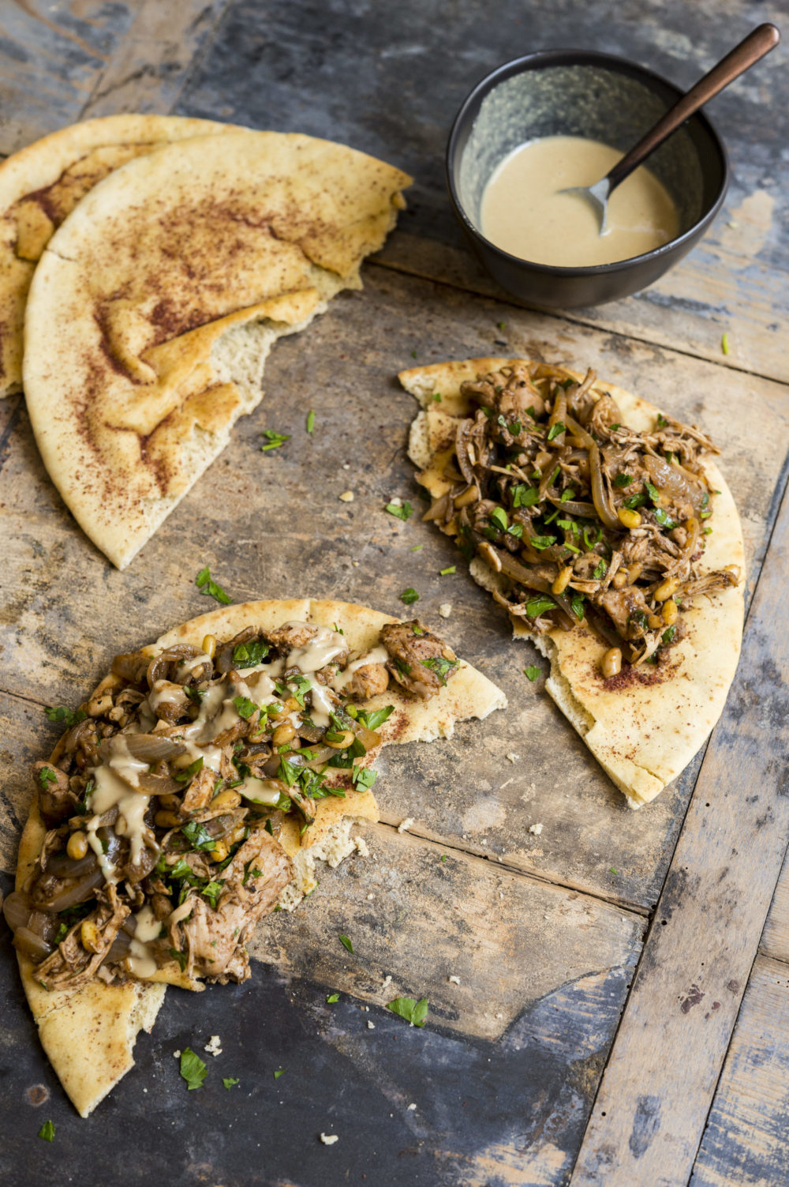
Musakhan

2 pounds boneless, skinless chicken thighs, trimmed
Kosher salt and ground black pepper
6 tablespoons extra-virgin olive oil, divided
1 large yellow onion, halved lengthwise and thinly sliced
4 garlic cloves, thinly sliced
4 tablespoons ground sumac, divided
2 teaspoons sweet paprika
3 cups water
4 8-inch pita bread rounds
1/2 cup flat-leaf parsley leaves, chopped
Tahini, to serve

Use paper towels to pat the chicken dry, then season with salt and pepper. In a large Dutch oven over medium-high, heat 1 tablespoon of the oil until just smoking. Add half of the chicken in a single layer and cook until well browned, 5 to 7 minutes. Transfer to a bowl. Repeat with another tablespoon of oil and the remaining chicken. Set the chicken aside.

With the pot over medium, heat 2 tablespoons of the remaining oil. Add the onion and cook, stirring, until softened slightly, about 5 minutes. Add the garlic, 3 tablespoons of the sumac and paprika. Cook, stirring, until fragrant, 30 to 60 seconds. Add the water, stir to combine and bring to a simmer. Return the chicken and any juices to the pot. Cover, reduce the heat to medium-low, and simmer until tender, 25 to 30 minutes.

Heat the oven to 450ºF with a rack in the middle position. Use a slotted spoon to transfer the chicken to a bowl. Use 2 forks to shred the meat into bite-size pieces. Bring the liquid in the pot to a simmer over medium-high. Cook, stirring, until most of the moisture has evaporated, 10 to 15 minutes. Return the chicken to the pot. Taste and season with salt and pepper. Cover and set aside.

Brush the pita on both sides with the remaining 2 tablespoons oil and arrange the rounds on a rimmed baking sheet. Bake until heated through and softened, 5 to 7 minutes. Sprinkle with the remaining 1 tablespoon sumac, then cut each round in half and transfer to a platter. Stir the parsley into the chicken and transfer to a serving bowl. Serve the chicken with the pita and tahini for drizzling.

