Grilled Jalapeño-Marinated Steak Sandwiches With Charred Onions and Cotija Mayo Recipe
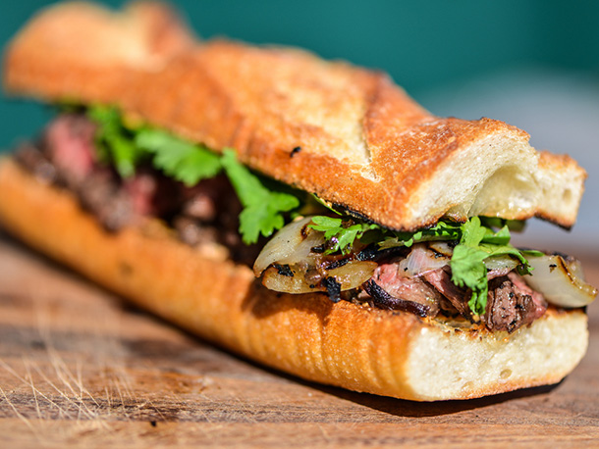
For the Cotija Mayo
1/4 cup mayonnaise
1/3 cup finely grated cotija cheese
2 tablespoons sour cream
1 tablespoon lime juice from 1 lime
1 teaspoon chili powder
1/2 teaspoon cayenne pepper

For the Marinade
1/3 cup juice from about 4 limes
3 tablespoons olive oil
2 medium jalapeños, stemmed and roughly chopped
2 teaspoons freshly minced garlic (about 2 medium cloves)
1 tablespoon dark brown sugar
1 tablespoon soy sauce
1 tablespoon apple cider vinegar
1 teaspoon Kosher salt
1 teaspoon freshly ground black pepper

1 pound hanger steak, trimmed of any hard fat and butterflied if thick (see note)
1 medium onion, cut into 1/2-inch slices and skewered horizontally
1 handful fresh cilantro leaves
1 baguette
Extra-virgin olive oil, for brushing

For the Cotija Mayo: Whisk together mayonnaise, cheese, sour cream, lime juice, chili powder, and cayenne pepper in a small bowl. Set aside.

For the Marinade: Place lime juice, olive oil, jalapeños, garlic, brown sugar, soy sauce, vinegar, salt, and pepper in the jar of a blender. Puree until smooth.

Place steak in a large resealable plastic bag. Pour in marinade and seal, removing as much air as possible. Let marinate for 30 to 60 minutes while preparing grill.

Light one chimney full of charcoal. When all the charcoal is lit and covered with gray ash, pour out and arrange coals on one side of the charcoal grate. Set cooking grate in place, cover grill and allow to preheat for 5 minutes. Clean and oil the grilling grate. Remove steak from marinade, place on hot side of grill, and cook until deeply browned on both sides and an instant read thermometer registers 125°F when inserted into center of meat. Remove from grill and let rest for 10 to 15 minutes. Slice into 2 inch portions with the grain, then slice against the grain into 1/4 to 1/2 inch strips.

While steaks rest, brush onions with oil and place on hot side of grill. Cook until charred on both sides and slightly softened, 4 to 5 minutes per side. Transfer to cutting board, remove skewer, and roughly chop.

Slice baguette into 4 6-inch portions and halve each portion lengthwise. Brush cut side of each baguette with oil. Grill baguette over hot side of grill, cut side down, until lightly browned, about 1 minute. Remove to plate.

Spread cotija mayo on top and bottom halves of bread. Top bottom halves of bread with steak, onions, and cilantro.

Place sandwiches on cool side of grill, cover, and cook until warmed through, 3 to 5 minutes. Transfer to a plate or tray and serve immediately.

