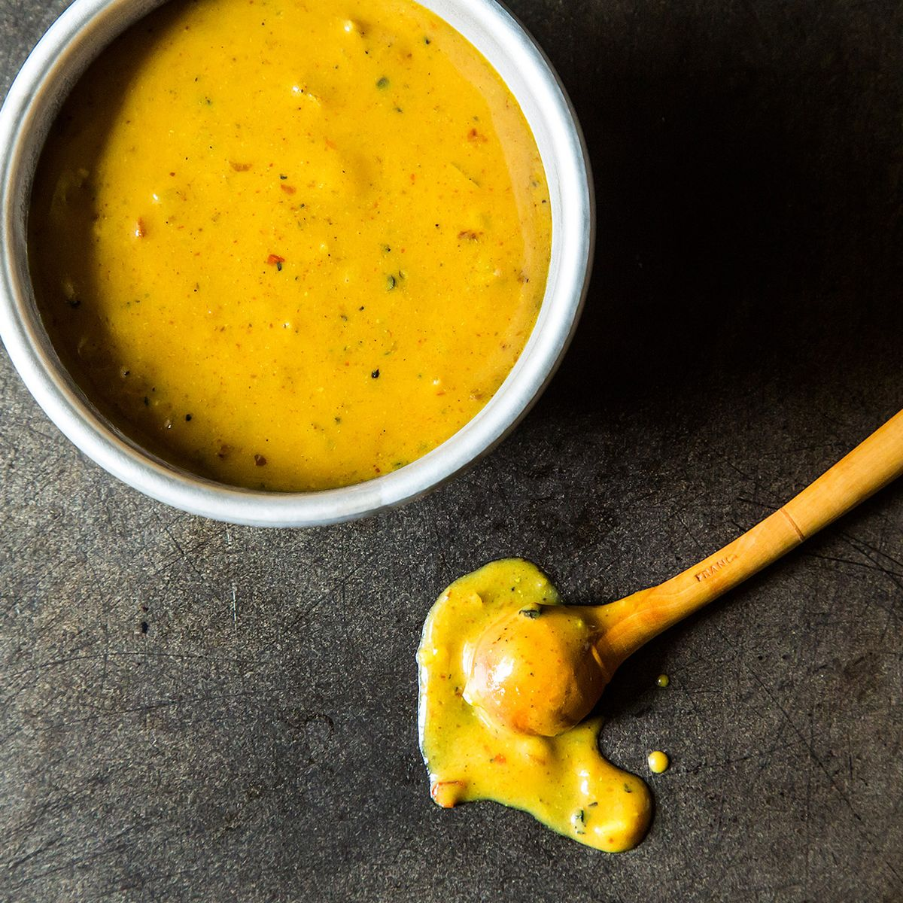
Mustard Base BBQ
3/4 Cup Yellow mustard
1/2 Cup honey
1/4 Cup Apple cider vinegar
2 Tablespoons Ketchup
1 Tablespoon Brown sugar
2 Teaspoons Worcestershire sauce
1 Teaspoon hot sauce or to taste
2 Tablespoons Butter, melted
1 Pinch of Nutmeg
1 Dash Liquid Smoke

Add all of the ingredients to a bowl and whisk to combine.

Pour into a jar with a lid and refrigerate 1 day to 1 week prior to serving for ultimate flavor.

