BBQ Chile Verde
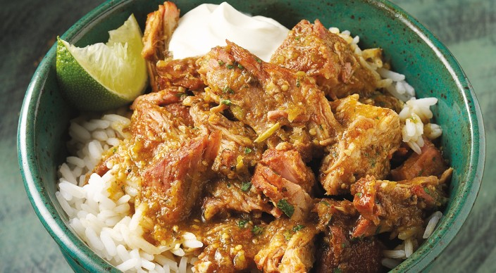
Rub
1 tablespoon kosher salt
2 teaspoons pure chile powder
2 teaspoons dried oregano
1 teaspoon granulated garlic
1 teaspoon ground cumin

And
1 boneless pork shoulder roast (Boston butt), 4 to 5 pounds, trimmed of excess surface fat
8 medium tomatillos, husked and rinsed
1 can (7 ounces) chopped green chiles with liquid
4 medium garlic cloves
1 small onion, roughly chopped
2 teaspoons dried oregano
¾ cup dark Mexican beer
¼ cup finely chopped fresh cilantro leaves
1 teaspoon Tabasco® chipotle pepper sauce
Kosher salt
Freshly ground black pepper
6 cups cooked white rice (optional)
1 cup sour cream
1 lime, cut into eighths

Fill a chimney starter to the rim with charcoal and burn the charcoal until it is lightly covered with ash. Separate the charcoal into two equal piles on opposite sides of the charcoal grate. Carefully place a large disposable foil pan between the two piles of charcoal and fill it about halfway with warm water. Let the coals burn down to low heat (250° to 350°F). Leave the lid off and all the vents open.

In a small bowl mix the rub ingredients. Coat the pork on all sides with the rub, massaging the spices into the meat. Allow the pork to stand at room temperature for 15 to 30 minutes before grilling.

In a food processor or blender, purée the tomatillos, canned chiles, garlic, onion, oregano, and beer.

Scatter the hickory chips over the two piles of charcoal. Brush the cooking grates clean. When the wood starts to smoke, place the pork in the center of the cooking grate, close the lid, and smoke-roast the pork over indirect low heat for 30 minutes.

Remove the pork from the grill and immediately close the lid to maintain the temperature. Place the pork in a large disposable foil pan. Pour the tomatillo mixture around the pork so it comes up the sides of the pork by 1 inch or so. Seal the pan tightly with foil, and place the pan in the center of the cooking grate. Cook the pork over indirect low heat, with the lid closed as much as possible, until the internal temperature of the meat reaches 190°F and the meat is so tender that it tears easily with a fork, 2 to 3 hours, depending on how steady the temperature is. To maintain the temperature, add 5 or 6 charcoal briquettes to each pile of charcoal every hour or so from the time you began to smoke the pork.

When the pork is fully cooked, carefully remove the pan from the grill. Unwrap the pork (be careful of the steam) and transfer it to a cutting board. Chop the pork into ½-inch chunks and shreds, discarding any large pieces of fat or tough pieces of meat. Pour the pan liquid into a large saucepan and spoon off most of the surface fat. Add the shredded meat and simmer the mixture uncovered for a few minutes to blend the flavors. Season with the cilantro, Tabasco, salt, and pepper. The chile verde may be made up to this point one day ahead of serving and refrigerated overnight. Warm the chile verde over a slow simmer before serving.

Serve the chile verde warm in bowls with rice. Pass the sour cream, limes wedges, and a bottle of Tabasco.

