Blueberry-Chipotle Barbecue Sauce

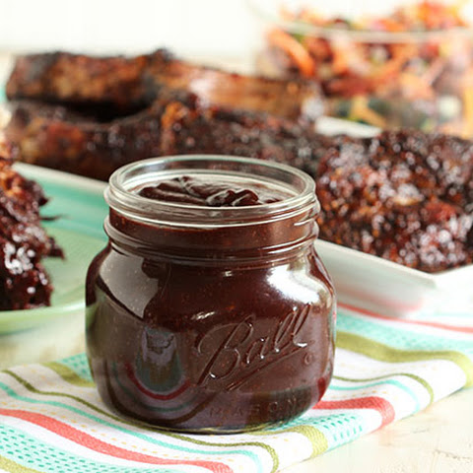
Ingredients

1 tablespoon olive oil
1 red onion, diced
2 garlic cloves, peeled and crushed
1 chipotle pepper
2 tablespoons adobo sauce
6 ounces tomato paste
1/2 cup balsamic vinegar
1 cup cider vinegar
2 cups fresh blueberries
3/4 cup packed light brown sugar
2 tablespoons Worcestershire sauce
1/4 cup molasses
1 tablespoon ground cumin
1 tablespoon chili powder
1 tablespoons cayenne pepper
1 tablespoon garlic powder
1/2 tablespoon ground cinnamon
1/2 tablespoon kosher salt
1/2 tablespoon fresh ground pepper

Instructions

In a large saucepan, heat the olive oil over med-high heat and add the onion. Saute until softened and add the garlic continuing to cook for 1 minute. Stir in the chipotle pepper, adobo sauce and tomato paste cooking until the mixture begins to caramelize and turn a deep burgundy color. Add both vinegars and scrape the bottom of the pan to release any brown bits.

Stir in the blueberries, brown sugar, worcestershire sauce, molasses, cumin, chili powder, cayenne, garlic powder, cinnamon, salt and pepper. Cook the mixture until the berries break down and the sauce begins to thicken. Simmer over low heat for 15-20 minutes. Turn off the heat and allow the sauce to cool to room temperature. Transfer to a blender and blend until smooth. Pour into an airtight container and store in the refrigerator for up to 7 days.

