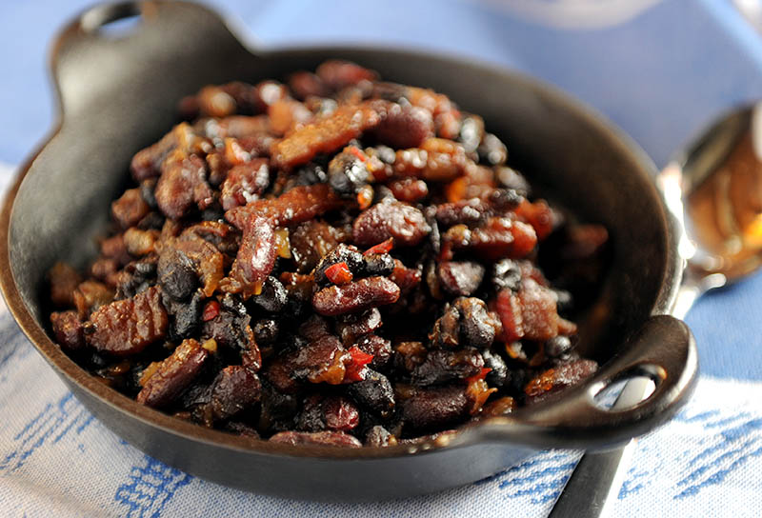
Raichlen Smoky Beans

Equipment: Weber Smokey Mountain smoker; hickory wood

6 ounces bacon, cut into 1/4-inch slivers
1 large onion, finely chopped (about 2 cups)
3 cloves garlic, minced
2 - 15-ounce cans great northern or kidney beans, drained and rinsed in a colander
1 - 15-ounce can black beans, drained and rinsed in a colander
1/3 cup packed dark brown sugar, or to taste
1/4 cup molasses, or to taste
1/4 cup your favorite barbecue sauce
1/4 cup ketchup
2 tablespoons Worcestershire sauce
1 tablespoon Dijon mustard
1 tablespoon dry mustard
2 tablespoons cider vinegar, or to taste
1/2 teaspoon liquid smoke
1/2 cup beer or water, or more as needed
Salt and freshly ground black pepper

Step 1: In a heavy pot, cook the bacon over medium heat to render the fat, about 5 minutes. Discard all but 2 tablespoons fat.

Step 2: Add the onion and garlic and cook until the vegetables are soft, about 5 minutes. Stir in the beans, sugar, molasses, barbecue sauce, ketchup, worcestershire sauce, mustards, vinegar, and liquid smoke. Add salt and pepper to taste.

Step 3: Set up your smoker following the manufacturer’s instructions and preheat to 225 degrees. Add the wood as specified by the manufacturer.

Step 4: Smoke the beans, uncovered, until thick and richly flavored, about 2 to 3 hours, stirring occasionally. (Add more beer or water as needed if beans seem too dry.)

