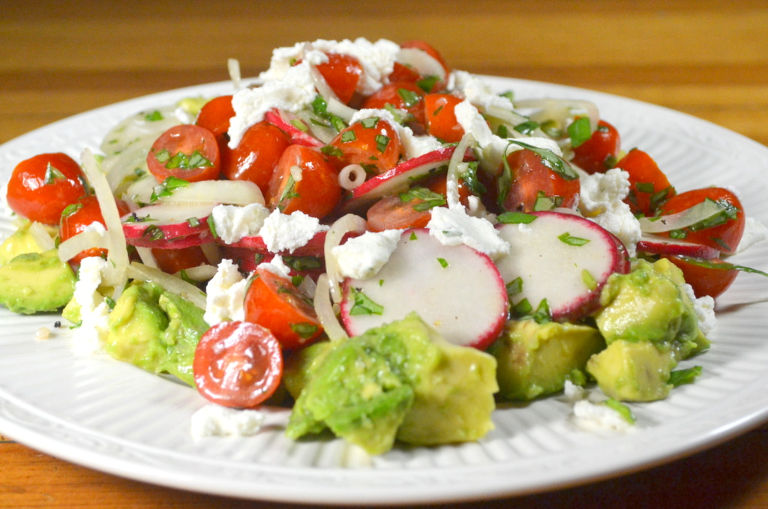
Avocado-Tomato-Radish Salad

Buttery avocados demand an acidic dressing to cut their richness. We were able to emulsify a highly acidic vinaigrette with a bit of mayonnaise to ensure cling. To add textural contrast, we steered clear of leafy greens and relied on crunchier vegetables and juicy fruits. Arranging the dressed avocado chunks below the other ingredients maximized visual appeal by preventing the avocado from turning the salad murky.

1 large shallot, sliced thin
3 tablespoons red wine vinegar
1 garlic clove, minced
½ teaspoon mayonnaise
Salt and pepper
3 tablespoons extra-virgin olive oil
3 avocados, halved, pitted, and cut into 3/4-inch pieces
12 ounces cherry tomatoes, quartered
3 radishes, sliced thin
½ cup chopped fresh basil
3 ounces ricotta salata, shaved thin

Crumbled feta cheese can be substituted for the ricotta salata.

1. Place shallot in 2 cups ice water and let stand for 30 minutes. Drain and pat dry with paper towels.

2. Whisk vinegar, garlic, mayonnaise, ¼ teaspoon salt, and ¼ teaspoon pepper in nonreactive bowl until mixture appears milky and no lumps remain. Whisking constantly, slowly drizzle in oil. (Dressing should appear homogeneous, glossy, and slightly thickened, without pools of oil on surface.)

3. Gently toss avocados, 2 tablespoons dressing, and ½ teaspoon salt in bowl. Transfer avocados to large platter or individual plates.

4. Toss shallot, tomatoes, radishes, and basil with remaining dressing. Spoon tomato mixture over avocados and sprinkle with ricotta salata. Serve immediately.

