Kosher salt and pepper
4 (6- to 8-ounce) boneless, skinless chicken breasts, trimmed
4 slices bacon, cut into 1-inch pieces
1 shallot, minced
2 garlic cloves, minced
3 tablespoons extra-virgin olive oil, plus extra as needed
2 teaspoons cider vinegar
2 teaspoons Dijon mustard
Pinch cayenne pepper
12 ounces cherry tomatoes, quartered
2 celery ribs, minced
¼ cup chopped fresh basil

To ensure that the chicken cooks through, use breasts that weigh no more than 8 ounces and pound them until they are 1 inch thick. Make sure to start with cold water in step 1.

1. Dissolve 1/4 cup salt in 6 cups cold water in Dutch oven. Cover chicken with plastic wrap and pound to even 1-inch thickness.

2. Submerge chicken in water. Heat pot over medium heat until water registers 170 degrees. Turn off heat, cover, and let sit until chicken registers 165 degrees, 15 to 17 minutes. Transfer chicken to paper towel–lined baking sheet. Refrigerate until chicken is cool, about 30 minutes.

3. Cook bacon in 12-inch skillet over medium heat until crisp, 8 to 10 minutes. Using slotted spoon, transfer bacon to paper towel–lined plate; set aside. (You should have about 3 tablespoons fat in skillet; if not, add extra oil as needed to equal 3 tablespoons.)

4. Add shallot to fat left in skillet and cook over medium heat until softened, about 2 minutes. Stir in garlic and cook until fragrant, about 30 seconds. Transfer mixture to large bowl and let cool slightly. Whisk in oil, vinegar, mustard, cayenne, and 1/4 teaspoon salt until combined.

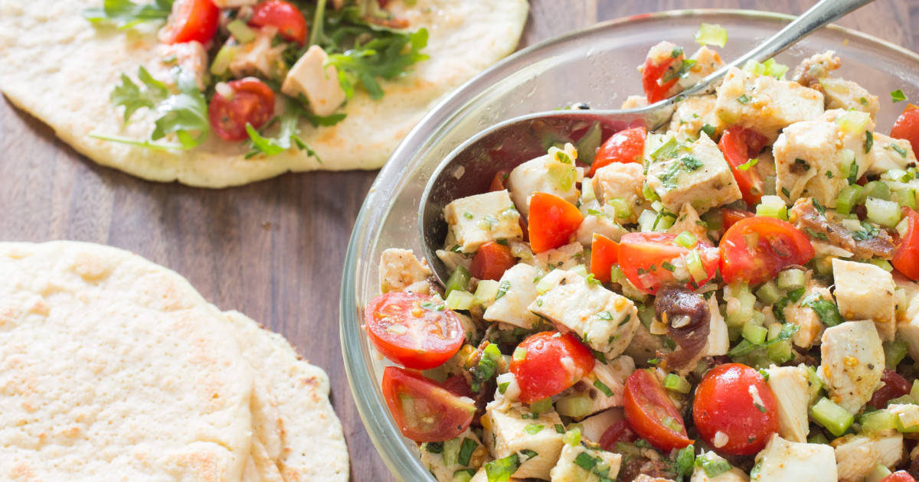
5. Pat chicken dry with paper towels and cut into 1/2-inch pieces. Add chicken, tomatoes, celery, basil, and crisp bacon to dressing and toss to combine. Season with salt and pepper to taste. Serve. (Salad can be refrigerated for up to 2 days. Let sit at room temperature for 30 minutes before serving.)

