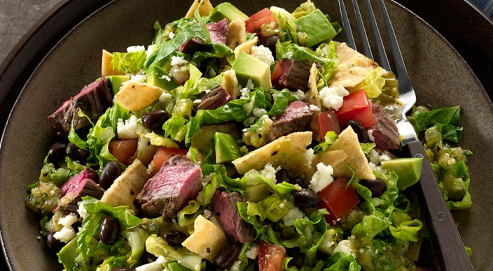
Skirt Steak Salad

2 tablespoons fresh lime juice
½ teaspoon dried oregano, preferably Mexican
¼ teaspoon freshly ground black pepper
Kosher salt
1-¼ pounds skirt steak, about ½ inch thick, trimmed of excess surface fat, cut crosswise into foot-long pieces

Salsa:
2 garlic cloves, unpeeled
1-½ pounds tomatillos, husked and rinsed
½ white onion, cut in half through the stem
1 jalapeño chile pepper
½ cup loosely packed fresh cilantro leaves
2 tablespoons fresh lime juice

Also:
1 can (15 ounces) black beans, rinsed and drained
6 ounces sturdy corn tortilla chips, coarsely broken (6 cups)
8 cups thinly sliced romaine or red leaf lettuce
2 ripe tomatoes, diced
1 Hass avocado, cut into small dice
4 ounces crumbled queso fresco cheese (1 cup)

Prepare the grill for direct cooking over medium heat (350° to 450°F).

In a large, shallow dish whisk the lime juice, oregano, pepper, and ½ teaspoon salt. Add the skirt steak and turn to coat in the mixture. Allow the steaks to marinate at room temperature for 30 minutes before grilling. Meanwhile, make the salsa.

Brush the cooking grates clean. Place the unpeeled garlic cloves in the center of a small square of aluminum foil and fold up the sides to create a packet. Grill the garlic packet, the tomatillos, the onion quarters, and the jalapeño, over direct medium heat, with the lid closed, until the vegetables are marked and softened, turning as needed. The tomatillos will take 7 to 10 minutes and the onion, jalapeno, and garlic will take about 15 minutes. Remove from the grill and set aside until cool enough to handle.

Increase the temperature of the grill to medium-high heat (400° to 500°F).

Peel the garlic. Cut the tomatillos in half or into quarters, and cut the onion into chunks. Remove any loose skin from the jalapeño and remove its seeds. In a food processor or blender process the garlic, tomatillos, onion, jalapeño, cilantro, lime juice, and ½ teaspoon salt until pureed.

Grill the steaks over direct medium-high heat, with the lid closed, until cooked to your desired doneness, 4 to 6 minutes for medium rare, turning once. Remove from the grill and let rest for 3 to 5 minutes. Cut the steaks into bite-sized pieces.

In a saucepan over medium heat, warm the beans. In a large salad bowl combine the beans, chips, lettuce, tomatoes, steak, 1 cup of the salsa, the avocado, and season with salt. Toss well. Sprinkle the cheese on top, and serve with the remaining salsa on the side.

