Lemony Fennel Slaw

1/2 cup mayonnaise
1 teaspoon finely grated lemon zest
1/4 cup fresh lemon juice
1 teaspoon sugar
1 small head Savoy cabbage, thinly sliced
1 small bulb fennel, thinly sliced
1/4 cup fennel fronds (leaves)
1/2 cup fresh Italian flat-leaf parsley
Kosher salt and freshly ground black pepper

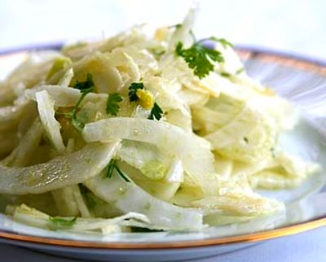
Whisk the mayonnaise, lemon zest, lemon juice and sugar in a large bowl. Add the cabbage, fennel, fronds and parsley in a large bowl and sprinkle with salt and pepper. Cover and refrigerate for at least 30 minutes.

