Parmesan-Bacon Butter

3 thick slices apple wood smoked bacon
1/4 cup plus 2 tablespoons finely grated Parmigiano-Reggiano cheese
1/4 cup (1/2 stick) unsalted butter, softened
1/4 teaspoon kosher salt
1/2 teaspoon freshly ground black pepper

Instructions

In a large skillet over medium heat, cook the bacon until it is crisp, 8 to 10 minutes, turning occasionally. Transfer to paper towels to drain and let cool. Finely crumble or chop the bacon. In a small bowl using a fork, combine all of the butter ingredients until well blended.

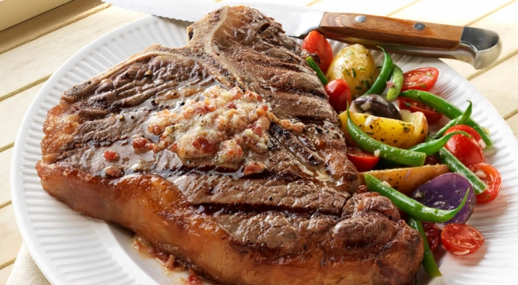
Serve over steaks.

