Butter
- 3 thick slices apple wood smoked bacon
- ¼ cup plus 2 tablespoons finely grated Parmigiano-Reggiano® cheese
- ¼ cup (1/2 stick) unsalted butter, softened
- ¼ teaspoon kosher salt
- ½ teaspoon freshly ground black pepper

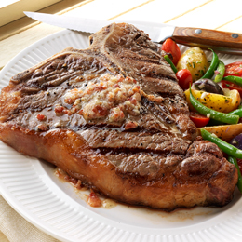
In a large skillet over medium heat, cook the bacon until it is crisp, 8 to 10 minutes, turning occasionally. Transfer to paper towels to drain and let cool. Finely crumble or chop the bacon. In a small bowl using a fork, combine all of the butter ingredients until well blended.

