Chi-Mex Corn

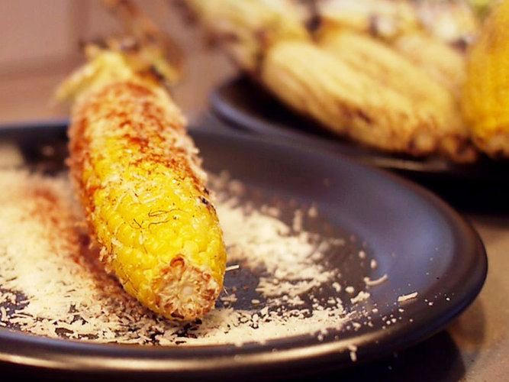
- 6 ears sweet corn in the husk
- 1 cup mayonnaise (preferably Hellmann's)
- 1 cup (about 4 ounces) freshly grated Cotija, Romano, or real Parmesan cheese
- 2 tablespoons pure chile powder (preferably ancho chili powder)
- Limes wedges for serving
- Butcher's string

Shuck the corn, stripping the husk back as though you were peeling a banana, but leaving the husk attached at the stem end (leave the stem on). Holding an ear of the corn in one hand, gather the husk together so that it covers the stem and then tie it with a piece of butcher's string, forming a sort of handle. Remove the corn silk. Repeat with the remaining ears of corn.
Place the mayonnaise, cheese, chile powder, and lime wedges in small attractive bowls. Have these ingredients ready on the table, along with butter knives for spreading the mayonnaise.
Set up the grill for direct grilling and preheat to high.
When ready to cook, arrange the corn on the hot grate so that the husks hang over the edge of the grill (this keeps them from burning) or place a folded sheet of aluminum foil under the husks to shield them. Grill the corn until nicely browned on all sides, 2 to 3 minutes per side (8 to 12 minutes in all), turning with tongs.
Transfer the grilled corn to a platter. To serve, tell everyone to spread mayonnaise on the corn, then working over a plate or the platter, sprinkle the ears with cheese and chile powder. Squeeze lime juice to taste over the corn and eat the kernels right off the cob.

