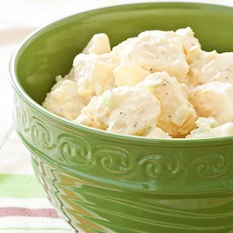
Amish Potato Salad

Ingredients
3 lbs Yukon gold potatoes, peeled
and cut into 3/4-inch chunks
Salt and pepper
1/3 cup cider vinegar
1/4 cup sugar
2 tablespoons yellow mustard
4 large hard-cooked eggs, peeled
1/2 teaspoon celery seed
3/4 cup sour cream
1 celery rib, chopped fine

COOK POTATOES Bring potatoes, 1 tablespoon salt, and enough water to cover by 1 inch to boil in large pot over high heat. Reduce heat to medium and simmer until potatoes are just tender, about 10 minutes.

PREPARE DRESSING While potatoes simmer, microwave vinegar and sugar in small bowl until sugar dissolves, about 30 seconds. Process vinegar mixture, mustard, 1 hard-cooked egg yolk (reserve white), celery seed, and ½ teaspoon salt in food processor until smooth. Transfer to medium bowl.

SEASON POTATOES Drain potatoes thoroughly, then transfer to large bowl. Drizzle 2 tablespoons dressing over hot potatoes and, using rubber spatula, gently toss until evenly coated. Refrigerate until cooled, at least 30 -minutes, stirring gently once to redistribute dressing.

ASSEMBLE Whisk sour cream into remaining dressing. Add remaining hard-cooked eggs and egg white to dressing and, using potato masher, mash until only small pieces remain. Add dressing and celery to cooled potatoes. Cover and refrigerate until chilled, about 30 -minutes. Season with salt and pepper. Serve. (Salad can be refrigerated in airtight container for 2 days.).

