Apple Slaw

¼ medium head green cabbage, thinly sliced (about 2 cups)
¼ medium head red cabbage, thinly sliced (about 2 cups)
1 large, crisp red apple, finely diced (do not peel)
½ cup mayonnaise
¼ cup plus 2 tablespoons crumbled blue cheese, divided
2 teaspoons Dijon mustard
2 teaspoons cider vinegar
½ teaspoon celery salt
¼ teaspoon kosher salt
¼ teaspoon freshly ground black pepper
¼ cup roughly chopped fresh Italian parsley

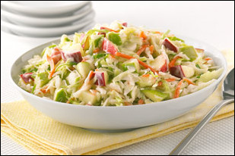
In a large bowl combine the cabbages and apple. In a small bowl whisk the mayonnaise, ¼ cup of the blue cheese, the mustard, vinegar, celery salt, salt, and pepper (some cheese lumps may still be apparent). Spoon over the cabbage mixture and toss to coat. Add the remaining 2 tablespoons blue cheese and parsley and toss again. Chill for at least 1 hour or up to 4 hours to allow the flavors to develop.

