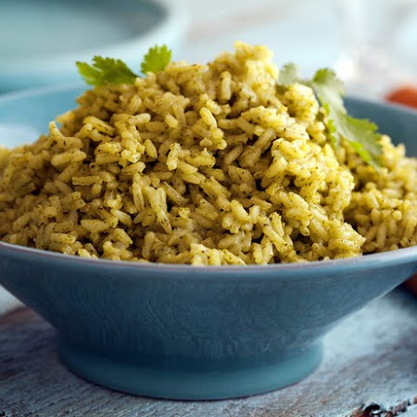
Cilantro Rice

Ingredients
3 ½ | cups packed cilantro leaves
3 | medium garlic cloves
1 | medium serrano chile, halved lengthwise and seeded
3 ⅓ | cups low-sodium chicken broth
1 | tbsp vegetable oil
½ | cup minced yellow onion
2 | cups long-grain white rice
1 | tbsp kosher salt

Directions
Combine cilantro, garlic, chile, 2 cups broth in a blender.
Heat oil in large frying pan over medium-high. Add onion, cook for 2 minutes. Add rice and salt, cook for 2 minutes. Add cilantro mixture and remaining 1 1/3 cups broth. Bring mixture to a boil then reduce heat to simmer. Cover and cook, 15 minutes. Fluff with a fork and serve.

