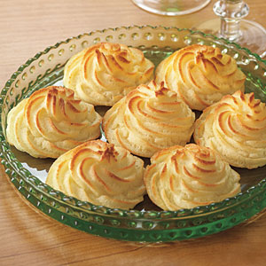
Duchess Potatoes

3 lbs russet potatoes
1 c heavy cream
6 tbsp butter, softened and divided
1 egg
1 egg yolk
½ tsp baking powder
Pinch of nutmeg
1¼ tsp salt
½ tsp pepper

Vegetable cooking spray

Poke the potatoes with a fork. Microwave the potatoes for 18-25 minutes, flipping them halfway through the cooking cycle.

Halve the potatoes and scoop out the tender, white flesh. Process the potato flesh through a potato ricer.

Add 1 cup heavy cream and 3 tbsp softened butter to the potatoes. Fold together.

Add 1 egg and 1 egg yolk. Fold the eggs in along with the baking powder, nutmeg, salt, and pepper.

Let the potato mixture cool to room temperature. Finally, fold in 3 tbsp butter.

Using a pastry bag, pipe the potatoes onto parchment paper. Spray the potato mounds with vegetable cooking spray.

Bake at 475 degrees in the upper-middle section of the oven for 15-20 minutes, or until nicely browned.

