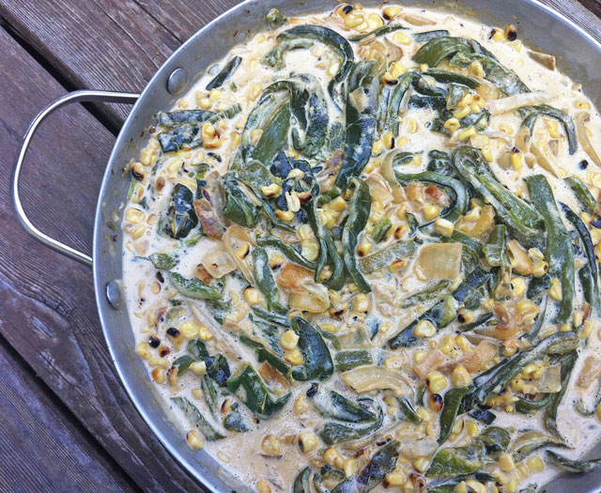
Creamy Poblano Rajas

6 fresh poblano chiles* (or canned, peeled)
3 tablespoons vegetable oil
1 medium white onion, thinly sliced
2 ears corn, kernels removed
1/4 cup heavy cream
1/4 cup Mexican crema or creme fraiche
1/2 cup, shredded Monterrey jack cheese
Kosher salt and fresh ground black pepper

Char the poblano chiles directly over the gas flame on the stove or under the broiler until blackened on all sides. Enclose in a plastic bag and let steam for about 10 minutes.

Add the oil to a heavy large skillet over medium heat. When the oil is hot, add the onion and saute until translucent, about 5 minutes. Add the corn and cook for an additional 3 minutes. Set aside.

Peel and seed the chiles. Cut the chiles into 1/4 to 1/2-inch strips (rajas) and add the strips to the onion and corn mixture and saute until the corn is tender, about 5 minutes. Add the heavy cream and Mexican crema and cook until bubbling, about for 8 minutes. Add the cheese and stir until melted and smooth. Season the rajas with salt and pepper, to taste. Transfer to a serving dish and serve.

*Cook's Note: The poblano chile is a fresh chile that ranges from mild to hot. It is a deep, dark green color and is large and wide with shiny skin. Ripened on the plant and dried it is known as "chile ancho" or "pasilla." They can also be found at most supermarkets or Latin specialty markets. Just keep your eye out, as some stores sell them fresh under the name "pasilla."

A great filling for tacos or topping for grilled arrachera. You can use virtually any chile but a mild poblano adds the perfect amount of spice to any dish.

