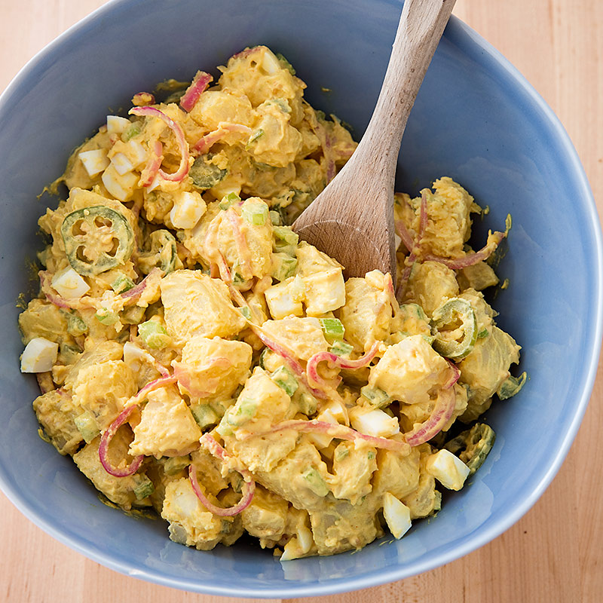
Texas Potato Salad

1/2 cup red wine vinegar
1 1/2 tablespoons sugar
Salt and pepper
1 teaspoon yellow mustard seeds
1/2 small red onion, sliced thin
2 jalapeño chiles (1 sliced into thin rings; 1 stemmed, seeded, and minced)
3 pounds Yukon Gold potatoes, peeled and cut into 3/4-inch pieces
6 tablespoons mayonnaise
6 tablespoons yellow mustard
1/4 teaspoon cayenne pepper
2 large hard-cooked eggs, cut into 1/4-inch pieces
1 celery rib, minced

1. Combine vinegar, sugar, 1 1/2 teaspoons salt, and mustard seeds in bowl and microwave until steaming, about 2 minutes. Whisk until sugar and salt are dissolved. Add onion and jalapeños and set aside until cool, 15 to 20 minutes. Strain onion and jalapeños through fine-mesh strainer set over bowl. Reserve pickled vegetables and vinegar mixture separately.

2. Meanwhile, combine potatoes, 8 cups water, and 1 tablespoon salt in Dutch oven and bring to boil over high heat. Reduce heat to medium and simmer until potatoes are just tender, 10 to 15 minutes.

3. Drain potatoes thoroughly, then transfer to large bowl. Drizzle 2 tablespoons reserved vinegar mixture over hot potatoes and toss gently until evenly coated. (Reserve remaining vinegar mixture for another use.) Refrigerate until cool, about 30 minutes, stirring once halfway through chilling.

4. Whisk mayonnaise, mustard, 1/2 teaspoon pepper, and cayenne together in bowl until combined. Add mayonnaise mixture, reserved pickled vegetables, eggs, and celery to potatoes and stir gently to combine. Season with salt and pepper to taste. Cover and refrigerate to let flavors blend, about 30 minutes. Serve. (Salad can be refrigerated for up to 2 days.)

