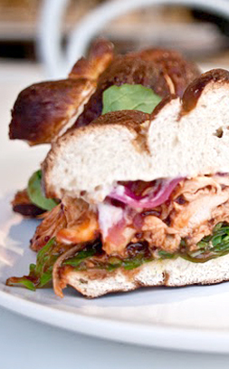
SimpleThings Pulled Chicken Sandwich

1 cup mayo, divided
3 cloves garlic, minced
1 tbsp lemon juice
1/2 tsp salt
1/2 tsp pepper

2 chicken breasts
Basic barbecue rub

2 Chipotle peppers in Adobo, minced

One red onion, sliced thinly
Red wine vinegar

4 ounces goat cheese
1/2 cup heavy cream

Arugula (or lettuce) to dress the sandwich
Substantial burger bun (pretzel bun?)

Place the red onion in a bowl and cover with red wine vinegar. Set aside until ready to serve.

Prepare garlic aioli. Mix 1/2 cup mayo with the minced garlic, lemon juice, salt, and pepper. Set aside in fridge until ready to serve.

Prepare chipotle sauce. Mix 1/2 cup mayo with the minced chipotles and adobo. Set aside in fridge.

Prepare goat cheese spread. Combine goat cheese and heavy cream and whisk until smooth. Refrigerate until ready to use.

Dust the chicken with barbecue rub. Cook the chicken and shred it.

Smear buns with aioli. Top with chicken. Dress with chipotle sauce and goat cheese spread. Top with pickled onions and arugula.

