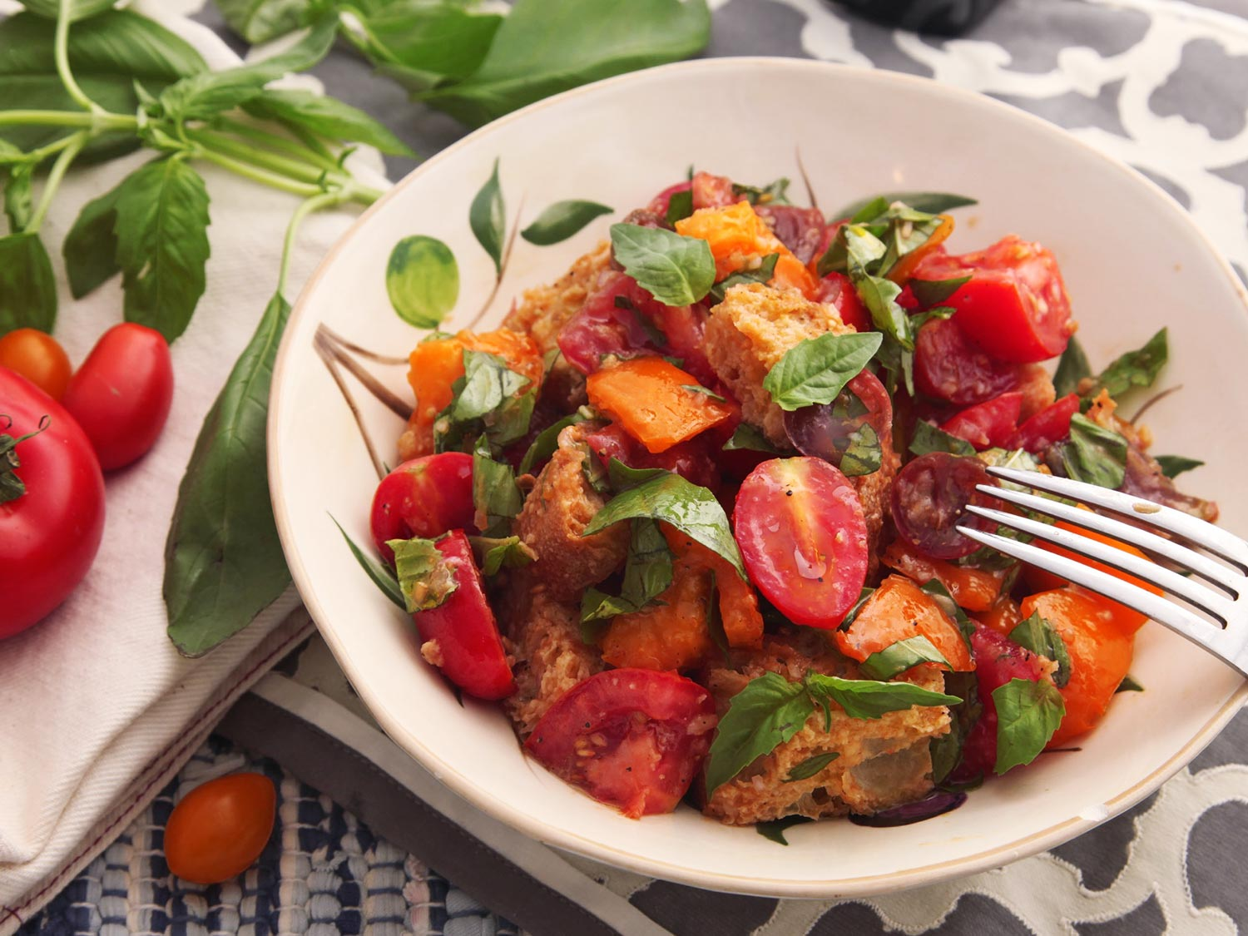
Panzanella Salad

WHY IT WORKS:
1/ Salting and draining the tomatoes produces tons of flavorful liquid to build up a lot of vinaigrette—essential for rehydrating the dried bread.
2/ Drying fresh bread in the oven produces a better texture than using stale bread.
3/ The tomato juice combines with vinegar to create a flavor-packed vinaigrette.

SPECIAL EQUIPMENT:
Rimmed baking sheet

NOTES:
Use a hearty, open-structured bread, like ciabatta or sourdough. This recipe calls for fresh bread, though dry, stale bread will work almost as well.

2 1/2 pounds mixed tomatoes, cut into bite-sized pieces
2 teaspoons kosher salt, plus more for seasoning
3/4 pound ciabatta or rustic sourdough bread, cut into 1 1/2-inch cubes (about 6 cups bread cubes)
10 tablespoons extra-virgin olive oil, divided
1 small shallot, minced (about 2 tablespoons)
2 medium cloves garlic, minced (about 2 teaspoons)
1/2 teaspoon dijon mustard
2 tablespoons white wine vinegar or red wine vinegar
Freshly ground black pepper
1/2 cup packed basil leaves, roughly chopped

1. Place tomatoes in a colander set over a bowl and season with 2 teaspoons kosher salt. Toss to coat. Set aside at room temperature to drain, tossing occasionally, while you toast the bread. Drain for a minimum of 15 minutes.

2. Meanwhile, preheat oven to 350°F and adjust rack to center position. In a large bowl, toss bread cubes with 2 tablespoons olive oil. Transfer to a rimmed baking sheet. Bake until crisp and firm but not browned, about 15 minutes. Remove from oven and let cool.

3. Remove colander with tomatoes from bowl with tomato juice. Place colander with tomatoes in the sink. Add shallot, garlic, mustard, and vinegar to the bowl with tomato juice. Whisking constantly, drizzle in the remaining 1/2 cup olive oil. Season dressing to taste with salt and pepper.

4. Combine toasted bread, tomatoes, and dressing in a large bowl. Add basil leaves. Toss everything to coat and season with salt and pepper. Let rest for 30 minutes before serving, tossing occasionally until dressing is completely absorbed by bread.

