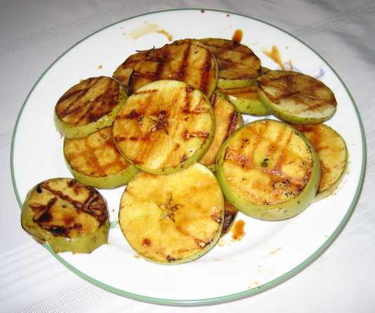
Apple “Steaks”

For the glaze:
- 1/2 cup apple cider
- 2 tablespoons honey
- 2 tablespoons lemon juice
- 2 tablespoons salted butter

- 4 medium or 3 large Granny Smith apples

Step 1: Make the glaze. Place the cider, honey, lemon juice, and butter in a heavy saucepan and boil until thick, syrupy, and reduced by about 1/3—6 to 10 minutes. Set the glaze aside.
Step 2: Set up your grill for direct grilling and preheat to high.
Step 3: Cut the apples crosswise into 1/2 inch thick round slices. Don’t worry about the seeds—they add a rustic charm to the preparation.
Step 4: Brush and oil the grill grate. Arrange the apple slices on the grate and grill until nicely browned and semi-soft, 3 to 5 minutes per side, rotating each slice 90 degrees after 1-1/2 minutes to lay on a handsome crosshatch of grill marks. Baste the apple slices with the cider glaze on both sides as they grill.
Step 5: Transfer the apple slices to a platter or plates. Drizzle any remaining glaze over them and serve at once.

