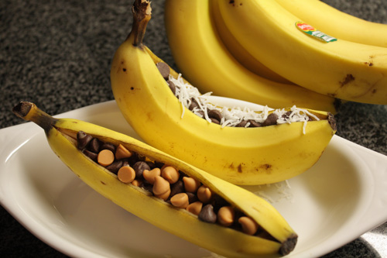
Banana Boats

Prep Time: 5 minutes

Cook Time: 10 minutes

Ingredients
Bananas

Chocolate chips, butterscotch, peanut butter chips, mini marshmallows, sweetened
coconut

Any other toppings you fancy

Preparation
- Choose your bananas.

- Slit the bananas lengthwise.

- Stuff them with any combination of toppings you desire. I am a big fan of dark chocolate and butterscotch.

- Wrap the bananas in foil and place on the grill. Grill with the cover on until toppings get melty and delicious.

- Eat with a spoon. (Insanely good over ice cream).

